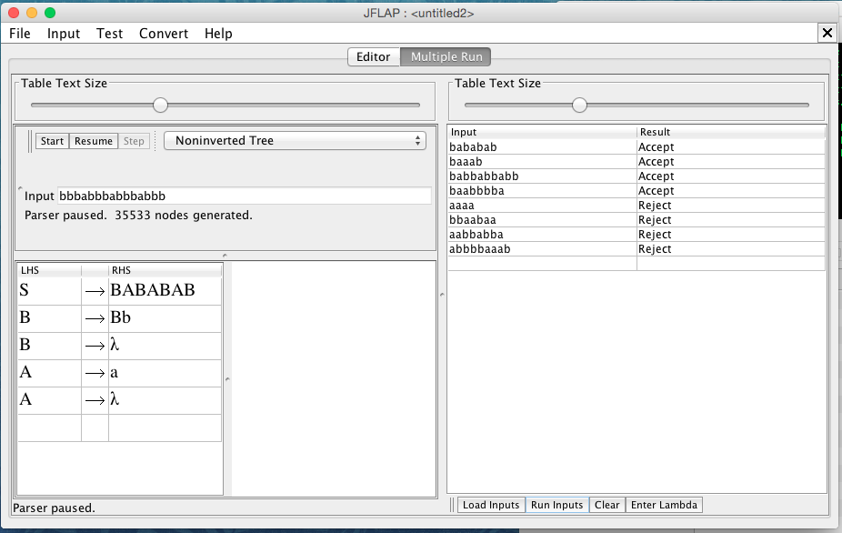

Test input (File included in the extras folder):

Correct:

* bababab
* baaab
* babbabbabb
* baabbbba

Incorrect:

* aaaa
* bbaabaa
* aabbabba
* abbbbaaab