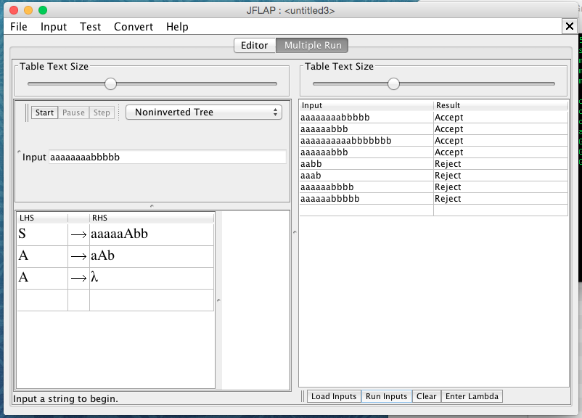

Test input (File included in the extras folder):

Correct:

* aaaaaaaabbbbb
* aaaaaabbb
* aaaaaaaaaabbbbbbb
* aaaaaabbb

Incorrect:

* aabb
* aaab
* aaaaaabbbb
* aaaaaabbbbb