We have been asked to find a context-sensitive grammar for the following language:

$$L=\{a^{n}b^{n}a^{2n}:n≥1\}$$

The associated grammar is the following:

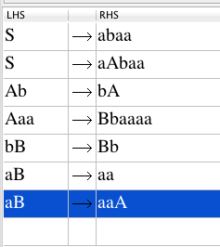

Test images below:

