We have been asked to find a context-sensitive grammar for the following language:

$$L=\{a^{n}b^{m}c^{n}d^{m}:n≥1,m≥1\}$$

We need a messenger variable, and as it travels, we choose whether we want to add and “a”, skips “b”’s then add a “c” OR if we want to add a “b” skip all “c”’s then add a “d”. It is important to reset the messenger variable after completing one cycle.

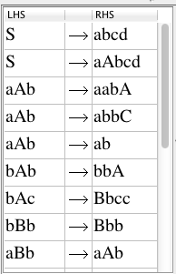

Base case:

Start an iteration:

If we want m:=m+1(1 more ‘b’ 1 more ‘d’)

If we want n:=n+1(1 more ‘a’ 1 more ‘c’)

Exit case:

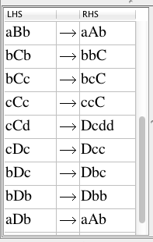

Some input testing:

