All strings in which the leftmost two symbols and the right most two symbols are identical.

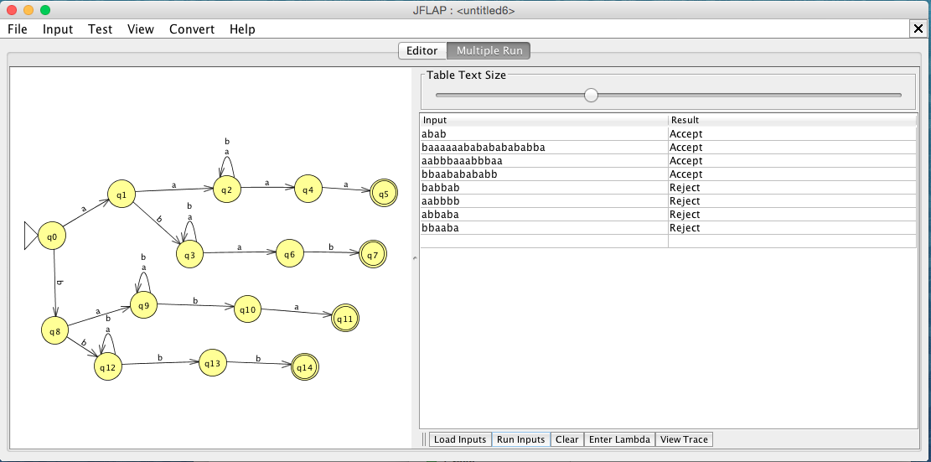

Accepted Strings:

abab

baaaaaababababababba

aabbbaaabbbaa

bbaababababb

Rejected Strings:

babbab

aabbbb

abbaba

bbaaba

∴ All strings in which the leftmost two symbols and the rightmost two symbols are identical.