Show that L = {an : n ≥ 0 , n ≠ 3 } is regular.

Soln : *Create a DFAM, s.t. L(M) =* an : n ≥ 0 , n ≠ 3 }.

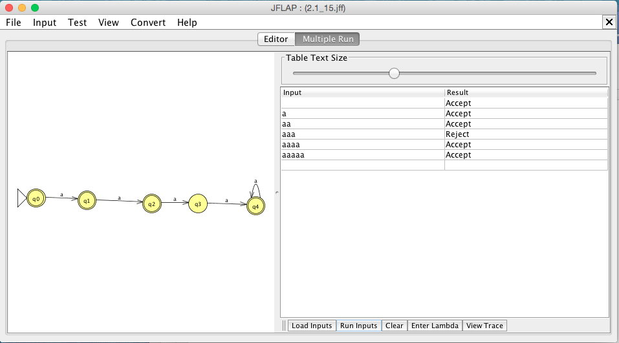

Accepted Strings:

λ

a

aa

aaaa

aaaaa

Rejected Strings:

aaa

∴Given DFA M we know L(M) = {an : n ≥ 0 , n ≠ 3 , showing us L is a regular language.