All strings with at least 2 a’s

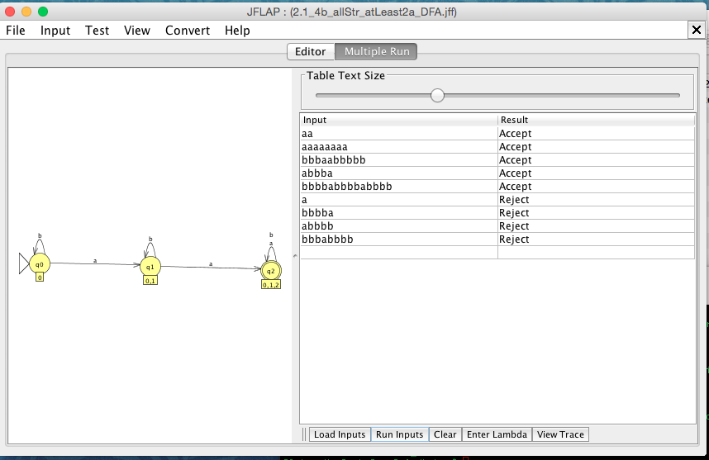

Accepted Strings:

aa

aaaaaaaa

bbbaabbbbb

abbba

bbbbabbbbabbbb

Rejected Strings:

a

bbbba

abbbb

bbbabbbb

∴ M s.t L(M) = {all strings with at least two a’s }