at least 1 b with exactly 2a's

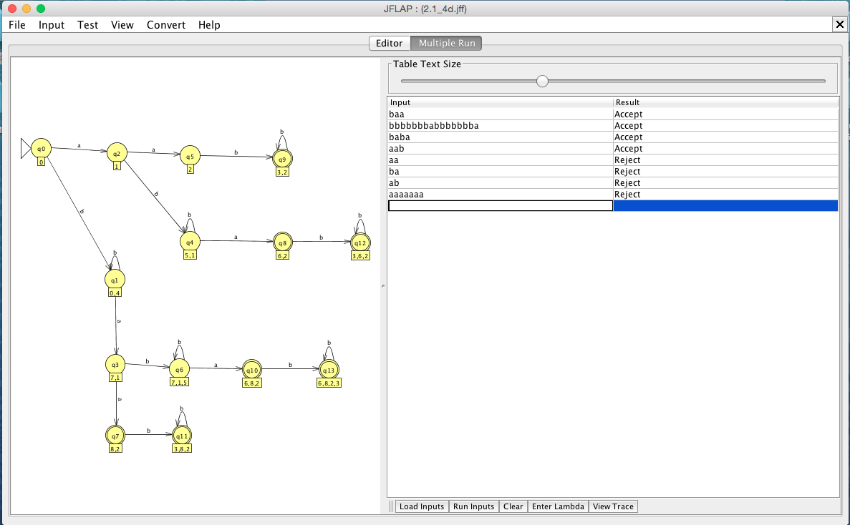

Accepted Strings:

baa

bbbbbbbabbbbbbba

baba

aab

Rejected Strings:

aa

ba

ab

aaaaaaa

∴ Constructed M s.t. L(M) =

{all strings with at least 1 b and exactly 2 a’s}