L = {w : na(w) mod 3 < 1 }

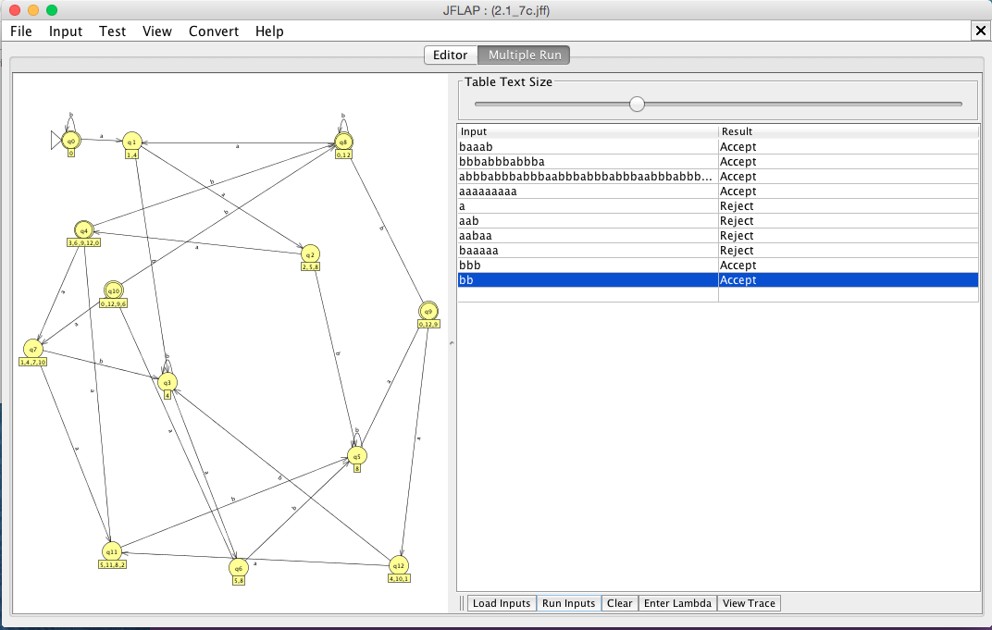

Strings Accepted:

b

bbbb

baaab

bbbabbbabbba

abbbabbbabbbaabbbabbbabbbaabbbabbbabbba

aaaaaaaaa

Strings Rejected:

a

aab

aabaa

baaaaa

­­­­­­∴ L = {w : na(w) mod 3 < 1}