L = {w : every run of a’s has length either two or three }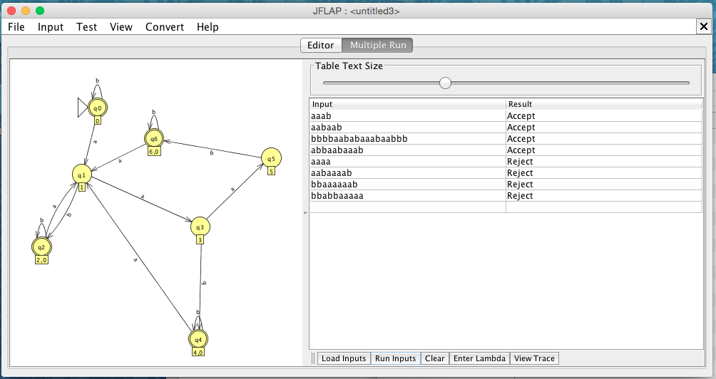

Accepted Strings:

aaab

aabaab

bbbbaababaaabaabbb

abbaabaaab

Rejected Strings:

aaaa

aabaaaab

bbaaaaaab

bbabbaaaaa

∴L = { w : every run of a’s has length either two or three}