1. Find an nfa with three states that accepts the language
   1. L = { an : n ≥ 1 } U {bmak : m ≥ 0, k ≥0 };

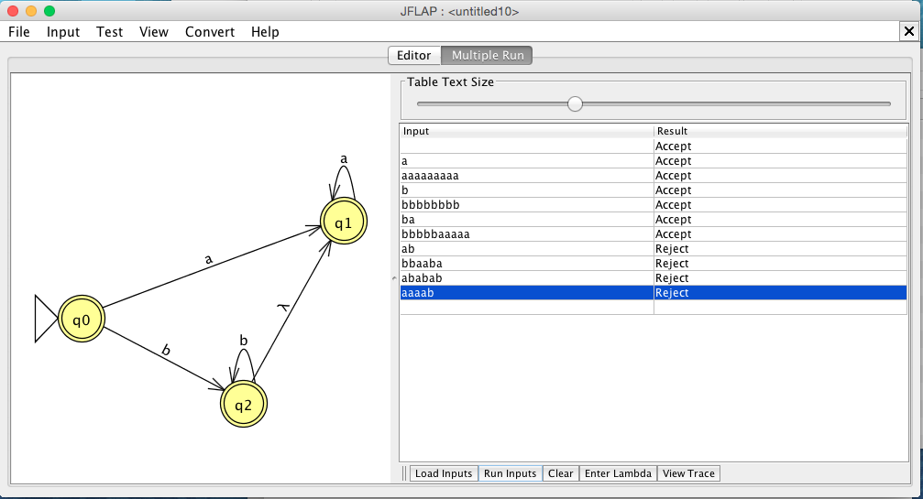

Accepted Strings:

a

aaaaaaaaa

b

bbbbbbbb

ba

bbbbbaaaaa

Rejected Strings:

ab

bbaaba

ababab

aaaab

PART A ANSWER:

∴Given NFA M, L(M) = { an : n ≥ 1 } U {bmak : m ≥ 0, k ≥0 };

1. Do you think the language in part (a) can be accepted by an nfa with fewer than three states?

Soln : Convert NFA 🡪 DFA, then Apply minimization algorithm:

Min DFA:

0 Equivalence Class

{0,2,3}, {}

1 Equivalence Class

{0,3}, {2}, {}

2 Equivalence Class

{0,3}, {2}, {}

So the final number of states can be no less than 3, so…

PART B ANSWER:

∴ No; even after the minimization algorithm the given NFA’s minimum number of states is still 3.