Design an nfa with no more than 5 states for the set {ababn : n ≥ 0 } U {aban : n ≥ 0 }.

So the NFA that must be constructed must accept all strings associated with both languages being unionized. The following NFA meets such constraints, along with the 5 state maximum requirement.

Let r1 = abab\* and r2 = aba\*

S.t L(r1 + r2) = L(r1) U L(r2)

∴ L(abab\* + aba\*) = {ababn : n ≥ 0 } U {aban : n ≥ 0 }.

NFA 🡪

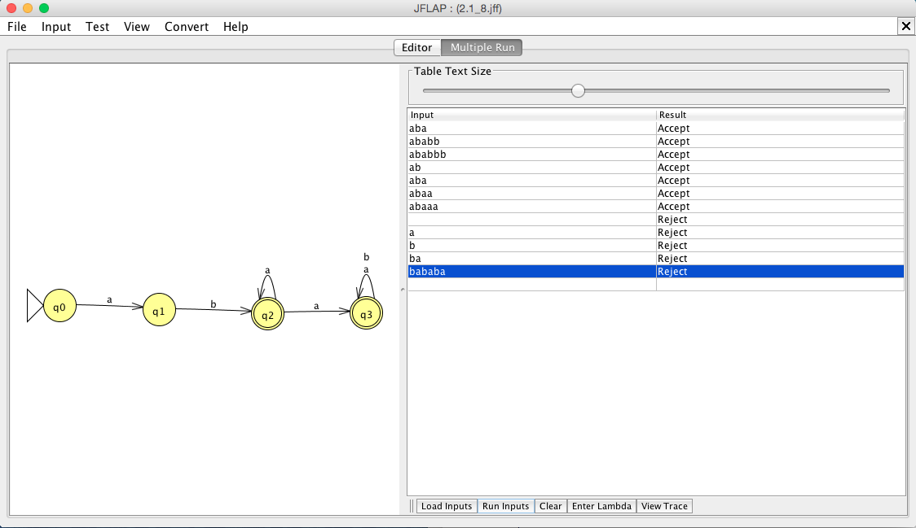

Accepted Strings:

aba

ababb

ababbbbbb

ab

aba

abaa

abaaaaaaaa

Rejected Strings:

λ

a

b

ba

bababa

∴An NFA M is no more than 5 states and represents {ababn : n ≥ 0 } U {aban : n ≥ 0 }.