1. Let L be the language in Example 2.5 of the text. Starting with the dfa in Figure 2.6, build dfa’s for
   * + 1. (a) L∗

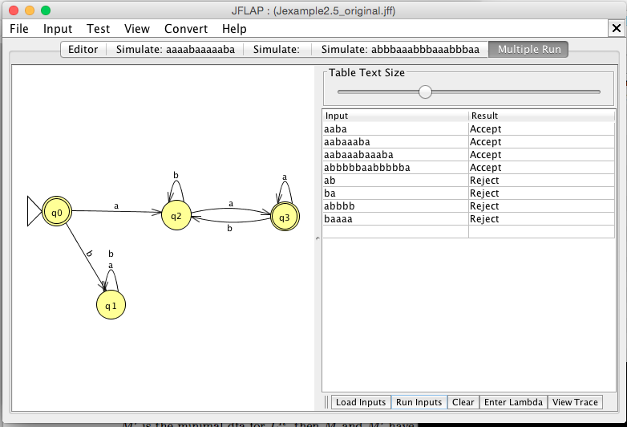

Accepted string tests:

aaba

aabaaaba

aabaaabaaaba

λ

Rejected strings tests:

abbbbbaabbbbba

ab

ba

abbbb

baaaa

∴ Given L = { awa : w ∈ {a,b}\* }

M s.t L(M) = L\*