*Note: I uploaded both Jexercise2.6_original* ***and*** *Jexercise2.6_modified for the sake of the relationship that M’ needs to have with M for testing purposes. I found having both files was helpful, but my apologies in advance if it causes more confusion than helpfulness!*

1. The dfa M in Jexercise2.6 accepts the string w = a. Modify M to create a new automaton  M′, so that L(M′) = L(M) − {a}.

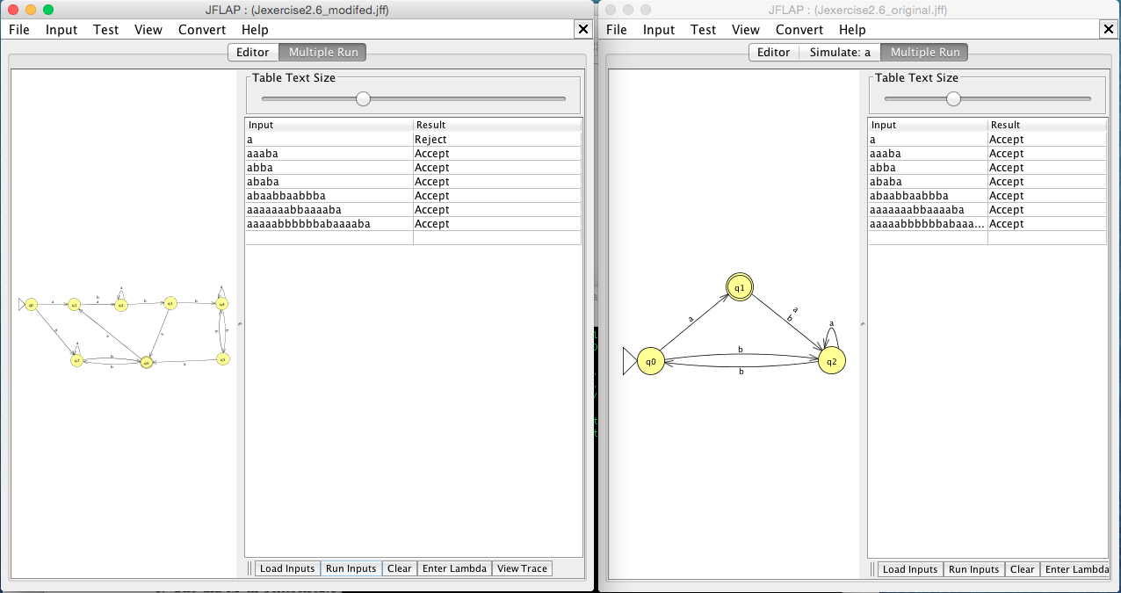

New Machine M’ Old Machine M

Tested under identical input:

a 🡨 Not accepted by M’

aaaba

abba

ababa

abaabbaabbba

aaaaaaabbaaaaba

aaaaabbbbbbabaaaaba

M accepts all input strings.

M’ accepts all except ‘a’ as input.

∴ Our new Machine M’ has been constructed such that … L(M’) = L(M) – {a}