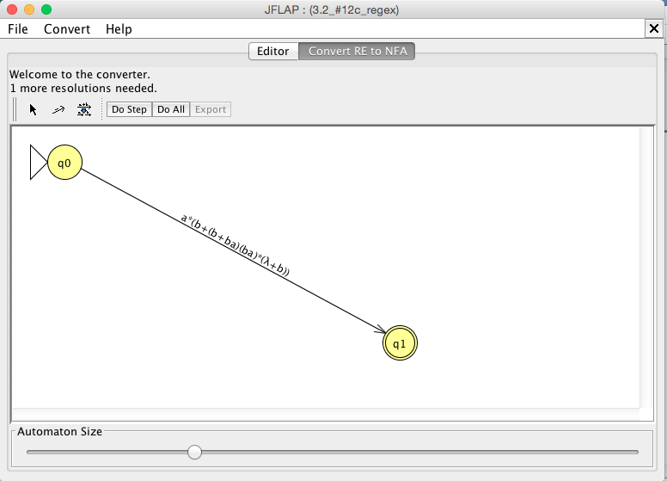 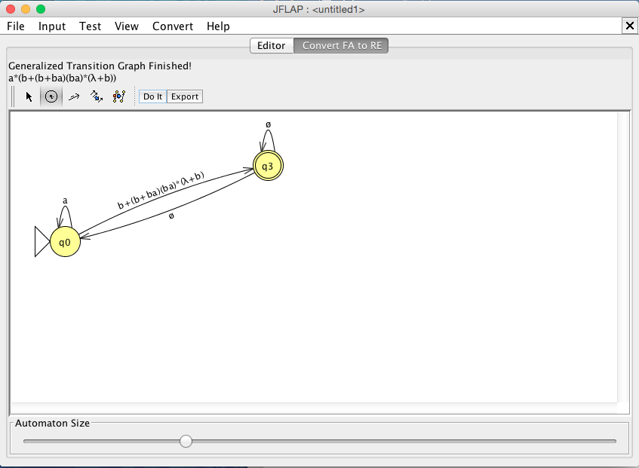

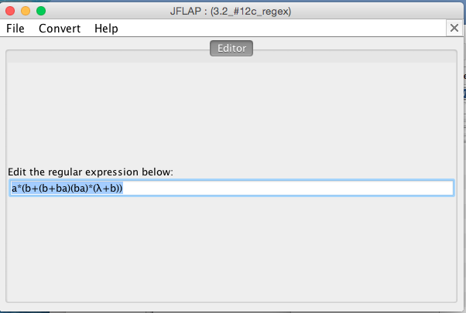

Two Equivalent NFA’s in Regular Expression form mentioned in Chapter 3 that produce the third image as a regular expression. View the JFF file in this folder to test the regular expression.

∴ a\*(b+(b+ba)(ba)\*(λ+b))