Using the *“canonical”* approach in JFLAP to create an NFA from the regular expression:

*ab\*aa + bba\*ab*

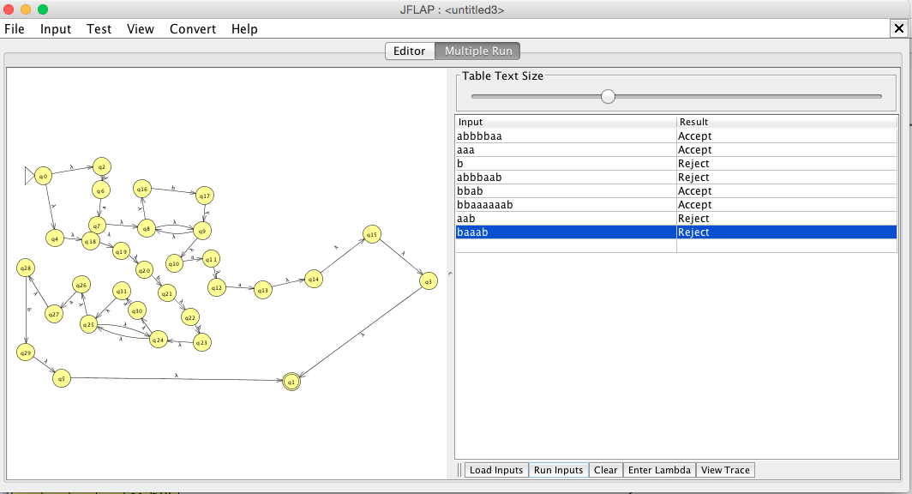

∴ The Machine above represents the canonical approach from *JFLAP* for the language *L(ab\*aa + bba\*ab).*