1. Find a regular expression for the language generated by the grammar

S → abA

A → bA | bB

B → bB | a

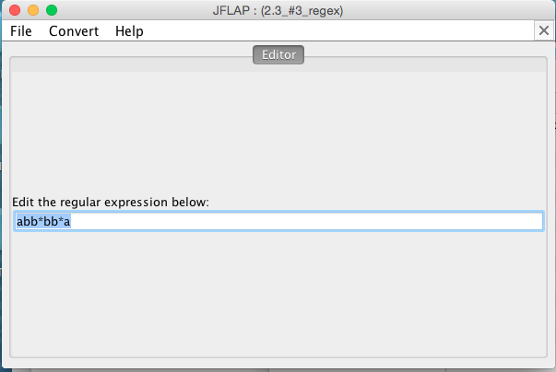

∴ All work is shown on paper’s turned into class lecture as the assignment specified.