*Initial Question:*

The operation changeleft replaces the leftmost symbol of any string by all other possible symbols, that is, for all a ∈ Σ

/Users/bmc/Desktop/Screen Shot 2016-09-21 at 10.15.21 AM.png

Extending this to languages, we define:

/Users/bmc/Desktop/Screen Shot 2016-09-21 at 10.15.38 AM.png

1. Let L be the language accepted by the finite automaton on Jexercise4.1. Construct a finite automaton for changeleft(L). Assume that Σ = {a, b, c}.

NOTICE: The question in the activities.pdf asks for a *“finite automata”*, while the handout for HW4 asks for *“an altered nfa”*. Both are in this folder and both should be labeled accordingly.

* So for some w L, let’s say: aa*b. Under changeleft(aa*b) = {ba*b, ca*b} should be our two options for the given word. The same logic goes for any initial letter. So my conclusion is that this will only change our initial transition with different initial options, for each letter that could be chosen. Then everything should act the same for the suffix of the word.

∴ Solution on the following page.

**Original:** M(L): 🡨 DFA

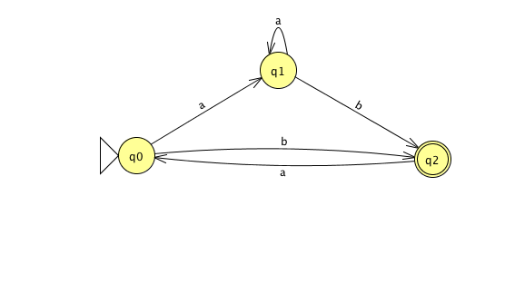

**Altered:** M(shiftLeft(L)) 🡨 NFA

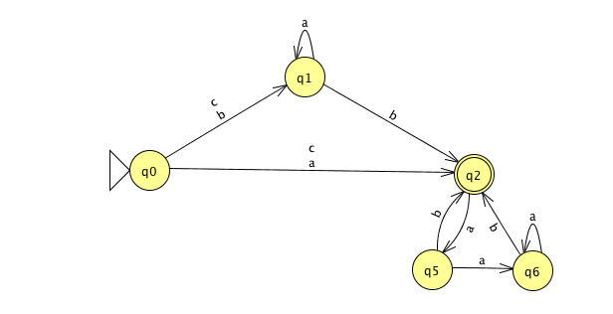

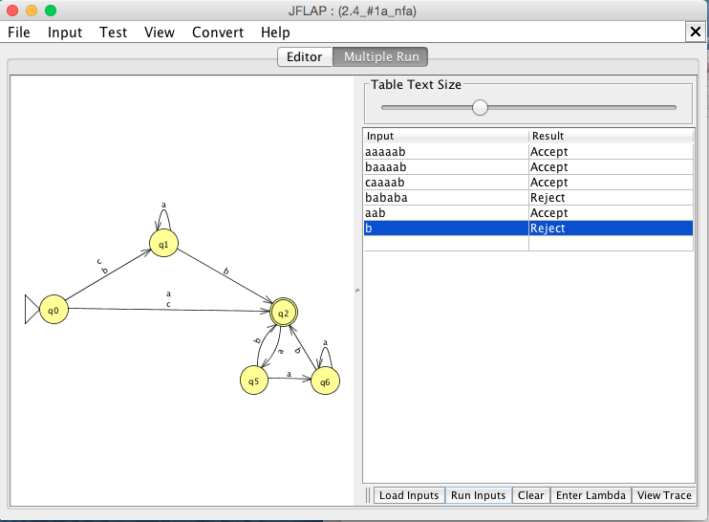

For the pdf’s requested dfa:

**Final:** M(shiftLeft(L)) 🡨 DFA