We are asked to transform the given grammar productions into Chomsky normal form.

S 🡪 baAB

A 🡪 bAB | λ

B 🡪 BAa | A | λ

1st Remove λ-productions

Vn = {A,B} then {A,B,S}

So we get

S 🡪 baAB | baB | baA | ba

A 🡪 bAB | bB | bA | b

B 🡪 BAa | A | Aa | Ba | a

2nd Remove Unit Productions

S 🡪 baAB | baB | baA | ba

A 🡪 bAB | bB | bA | b

B 🡪 BAa | A | Aa | Ba | a

A will turn into bAB | bB | bA | b

So we get

S 🡪 baAB | baB | baA | ba

A 🡪 bAB | bB | bA | b

B 🡪 BAa | bAB | bB | bA | b | Aa | Ba | a

3rd Convert to Chomsky Normal

Let, Bb = b

Aa = a

W = Bb B

X = Bba

Y = AB

Z = BA

So we get

S 🡪 XY | XB | XA | BbAa

A 🡪 BbY | BbB | BaA | b

B 🡪 ZAa | BbY | BbB | BbA | b | AAa | BAa | a

Bb 🡪 b

Aa 🡪 a

W 🡪 Bb B

X 🡪 BbAa

Y 🡪 AB

Z 🡪 BA

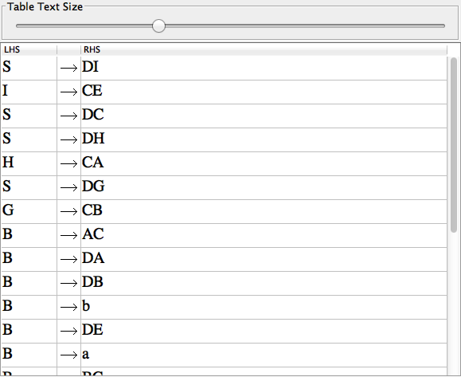

Is the best snap shot I could get. See attached .jff for more info.