We are asked to convert the productions we have determined so far by removing λ-productions, unit-productions, and useless-productions into Chomsky Normal Form.

From *Part (C)* we have the following grammar:

S 🡪 aAB

A 🡪 aaC | aa

C 🡪 aaC | aa

B 🡪 aC | a

Reminder: Chomsky Normal Form:

A 🡪 BC

A 🡪 a

The formal solution is attached to the .jff file and the image I will show shortly, but after I did this by hand I got the same thing, and in my opinion it is much more readable.

Let, Aa = a

D = AB

E = AaC

So,

S 🡪 AaD

A 🡪 AaE | Aa Aa

C 🡪 AaE | Aa Aa

B 🡪 AaC | a

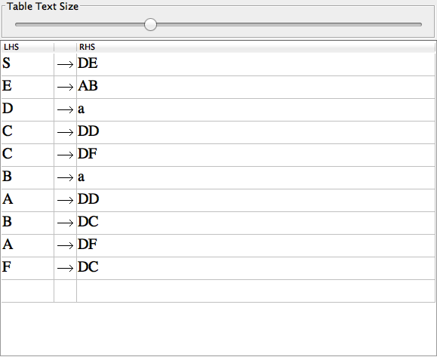

∴ Transformation to Chomsky Normal Form Complete.