Given the Grammar with productions

S 🡪 aAB

A 🡪 aaC

C 🡪 A

B 🡪 aC

C 🡪 λ

We are asked to remove all lambda productions.

This is done by the algorithm explained in Theorem 6.3.

1st Add all variables that have direct λ-productions: X 🡪 λ to a set Vn.

2nd Repeat until no more unique variables are added to Vn: Add all variables that have contact with λ-production Xi in V: Y 🡪 X1X2 … Xn, to Vn.

3rd Once Vn is found, construct some production P and replacing all possible combinations of nullable variables in Vn with λ.

Step 1: Vn = {C}

Step 2: Vn = {C, A, B}

Step 3: Replace all combinations of the variable A,B,C from productions of A,B,C with λ.

S 🡪 aAB

A 🡪 aaC | aaλ

C 🡪 A | λ

B 🡪 aC | aλ

C 🡪 λ

Final Step: Remove all λ’s and λ-productions.

S 🡪 aAB

A 🡪 aaC | aa

C 🡪 A

B 🡪 aC | a

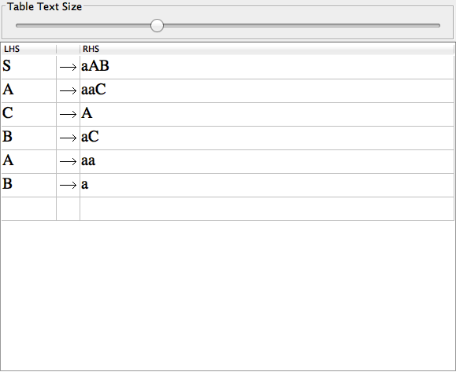

∴ λ-Production Removal Complete.