We are asked to remove all unit production from *Part (B)*.

The grammar productions we have are as follows:

S 🡪 aAB

A 🡪 aaC | aa

C 🡪 aaC | aa

B 🡪 aC | a

There exist no useless productions in the grammar from *Part (B).* This is because our derivations S 🡪\* xAy 🡪\* w. In other words, each variable is accessible, has a terminal we can use to complete the string, does not ‘*dead end’* in an endless loop, and is valid in producting unique words to the language the grammar generates. No disqualifying factors are broken with the grammar after λ-production and unit-production removal.

S 🡪 aAB

A 🡪 aaC | aa

C 🡪 aaC | aa

B 🡪 aC | a

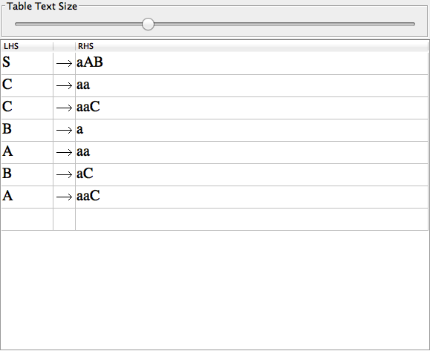

∴ Useless Production Removal Complete.