We have been asked to remove unit productions from *Part (A)* of this question.

S 🡪 aAB

A 🡪 aaC | aa

C 🡪 A

B 🡪 aC | a

Is our initial grammar. We can follow Theorem 6.4 in completing this task. Essentially the algorithm brings the one special case of production dependency, and we have that as well. This can be done by substituting the unit production out for all possible combinations of its dependent variables production(s)

S 🡪 aAB

A 🡪 aaC | aa

C 🡪 aaC | aa

B 🡪 aC | a

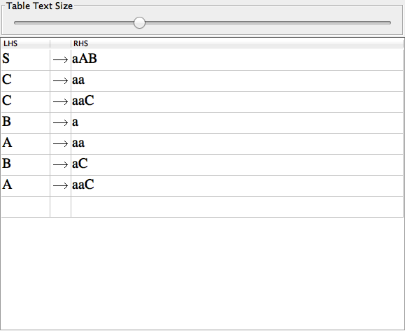

∴ Unit Production Removal Complete.