We have been asked to find an *NPDA* with no more than two internal states that accepts the language $L({aa}^{*}{ba}^{*}$).

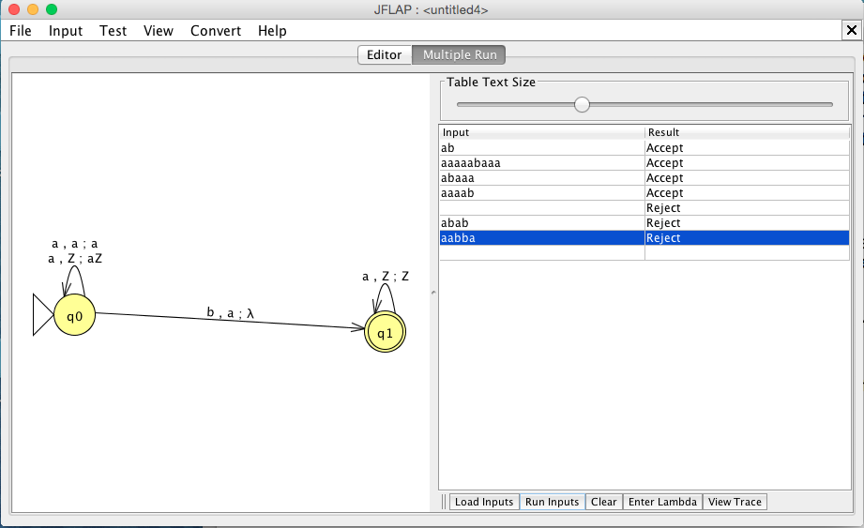

The key was to only keep track of the first ‘a’ appearing, then supplement it with a ‘b’ after any number of ‘a’s.

∴ The above image represents an *NPDA* with no more than two internal states to represent $L({aa}^{*}{ba}^{*}$).