We have been asked to construct an *NPDA* for the following language:

$L=\{a^{3}b^{n}c^{n} :n≥0\}$.

On the alphabet $Σ=\left\{a,b,c\right\}$.

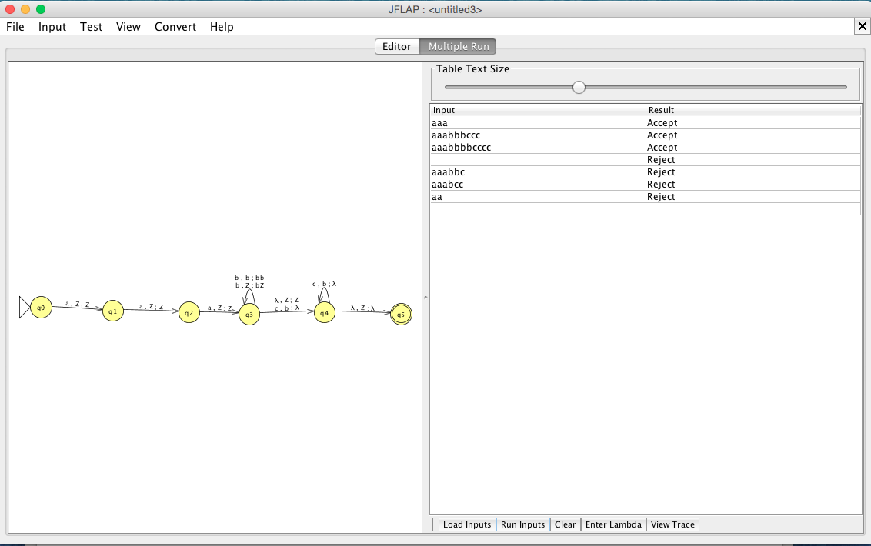

∴ The above *NPDA* accepts $L=\{a^{3}b^{n}c^{n} :n≥0\}$.