We are asked to construct an *NPDA* for the following language:

$L=\{w :n_{a}\left(w\right)= n_{b}\left(w\right)+ 1 \}$.

on the alphabet $Σ=\left\{a,b,c\right\}$.

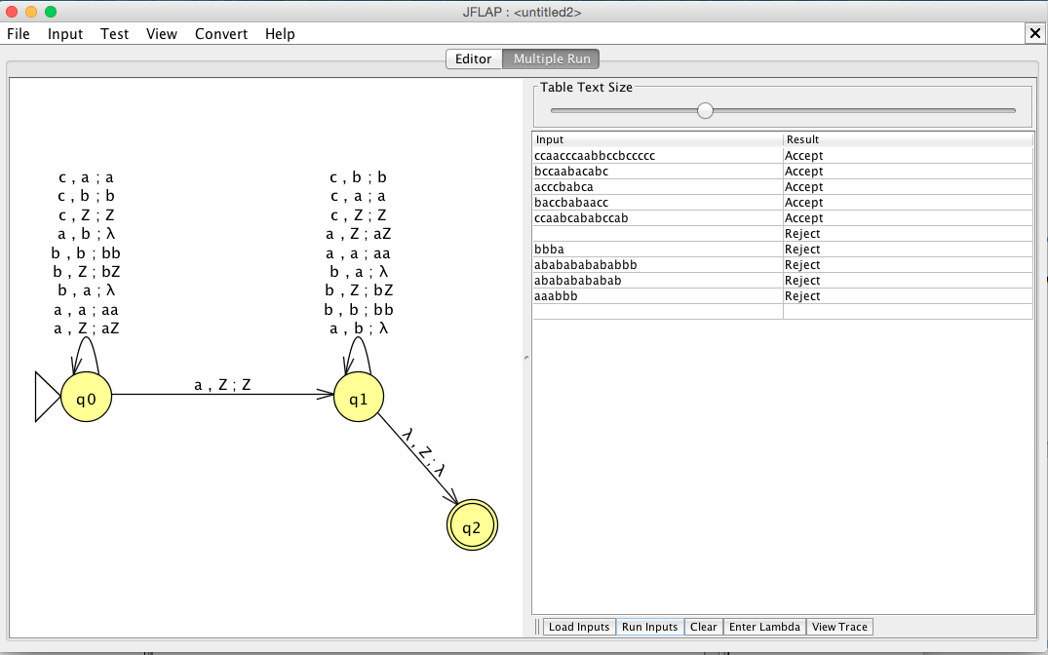

The three cases I found were:

Let wn annotate a word with the same number of a’s and b’s with any number of c’s.

*Case 1:*

wna

*Case 2:*

awn.

*Case 3:*

wnawn.

∴ The image shows the language $L=\{w :n_{a}\left(w\right)= n_{b}\left(w\right)+ 1 \}$ as an *NPDA.*