The given language is *non-deterministic* because of the last transition $δ\left(q_{f}, , z\right)$, which according to **definition 7.3’s second property** states that:

“if $δ\left(q_{i}, , z\right)$ occurs in some M, then $δ\left(q_{i}, c, z\right) must be empty for ∀_{c}∈Σ$.“

However, the automaton given in Example 7.4, as in all automaton, must initialize the stack with a Z, this means that there cannot exist another $δ\left(q_{i}, , z\right)$ without becoming ­*non-deterministic*. Since we see it twice, there is a contradiction with our definition, making the it an *NPDA,* but the language itself can be expressed as a *DPA.*

Therefore, we see that it is *non-deterministic*, because it has broken the second property of *determinism* for automaton that represent *context-free-languages*.

We can fix it simply, however, by changing the last transition from $δ\left(q_{0}, , z\right)=\{(q_{f}, z$)} ***to $δ\left(q_{0}, , z\right)=\{(q_{f},$*** )}.

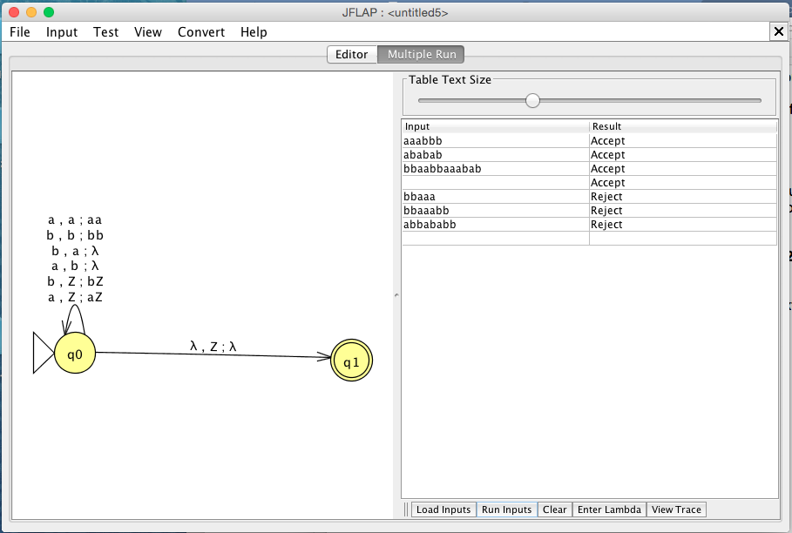

∴ *DPDA* to express the given *NPDA.*