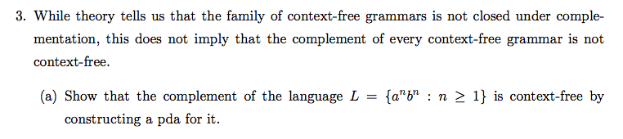

We can construct our Lc as the following union of L1 and L2 and L3 and L4.

This allows us to construct:

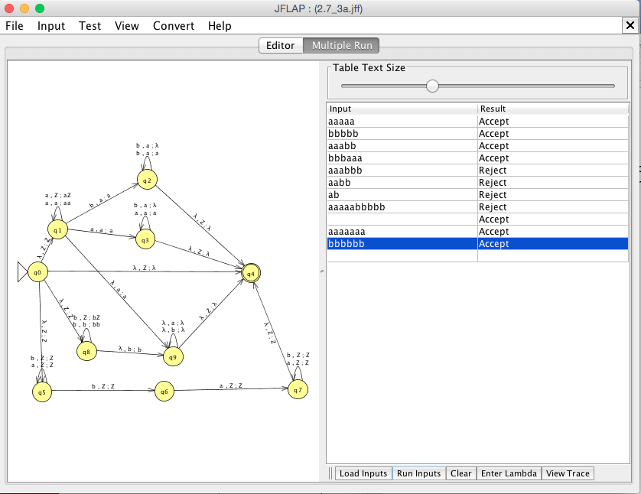

∴ Therefore, we can see that the compliment of our given language L illustrated in a DPDA illustrated above, concluding that the compliment of a context-free language is also context-free.