We have been asked to explain how a linear bounded automata could be constructed to accept the following language:

$$L=\left\{a^{m^{2}} \right| m^{2}≥1 \}$$

we can notice the pattern that is found in this language:

$$\{a, aaaa, aaaaaaaaa, aaaaaaaaaaaaaaaa, … \}$$

|  |  |  |
| --- | --- | --- |
| M=1 | 1 | BASE |
| M=2 | 4 | 3 |
| M=3 | 9 | 5 |
| M=4 | 16 | 7 |

The solution to this problem has three cases and requires a 2 tape linear bounded automaton. The second tape is to keep track of the differences between each iteration we need to add (or shift) the first tape.

∴ 2-Tape LBA to accept

|  |  |  |  |  |  |  |  |  |  |
| --- | --- | --- | --- | --- | --- | --- | --- | --- | --- |
| [ | a | a | a | a | ] |  |  |  |  |
| [ | a | a | a | a | ] |  |  |  |  |

accept a

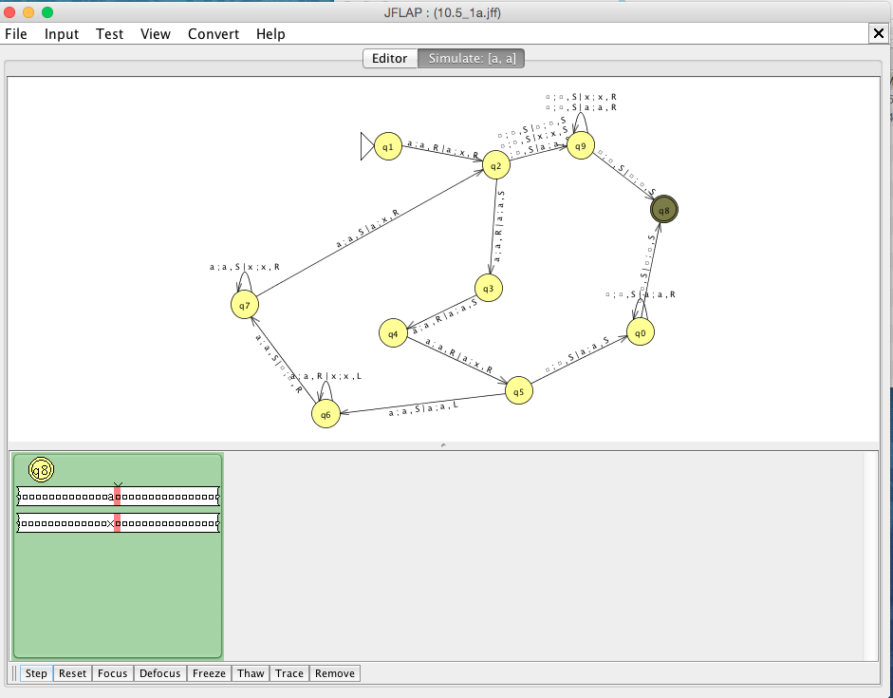

accept aaaa

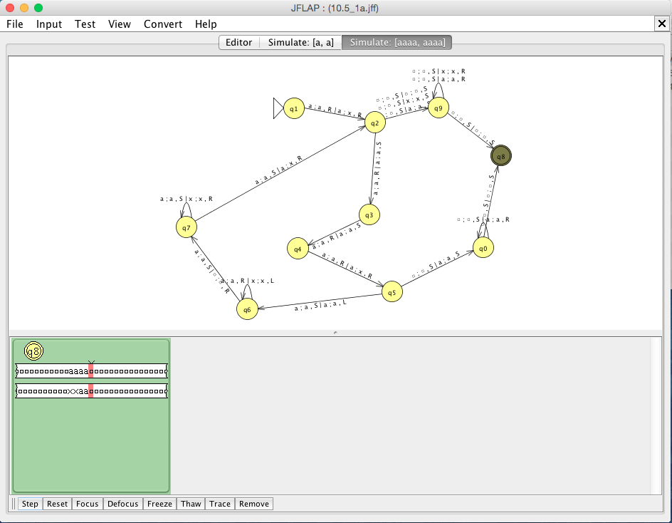

accept aaaaaaaaa (9a’s)

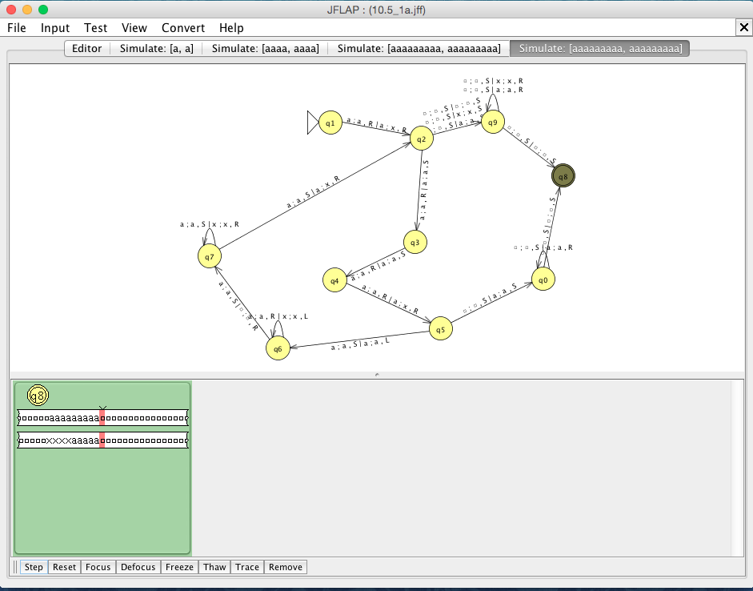

Reject aaaaaaaaaaaa (12 a’s)

