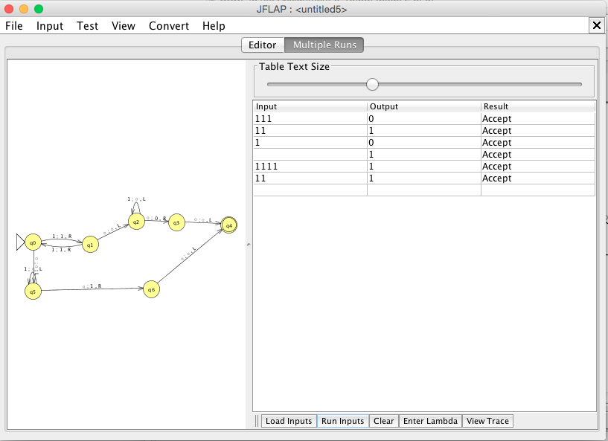

∴ A TM transducer that decides $f\left(w\right)= 1 if w is odd, 0 if w is even.$ Where w is a string of unary 1’s.