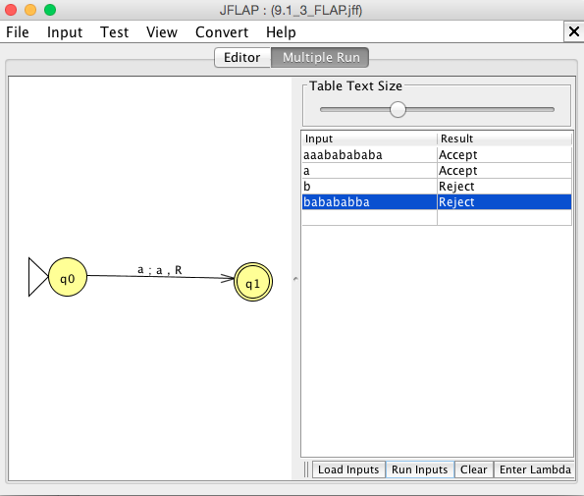

∴ A 2 state machine to represent the language a(a+b)\*. So yes, a 2 state machine is possible.