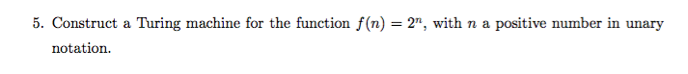

Example of Unary notation:

1, 11, 111, 1111, 11111, ...

We can see that $\frac{x}{2^{n}}=1→x=2^{n}$, so by keeping track of even multiples, we should be able to keep track of whether a given word on our input tape is acceptable.

Accept 8 1’s

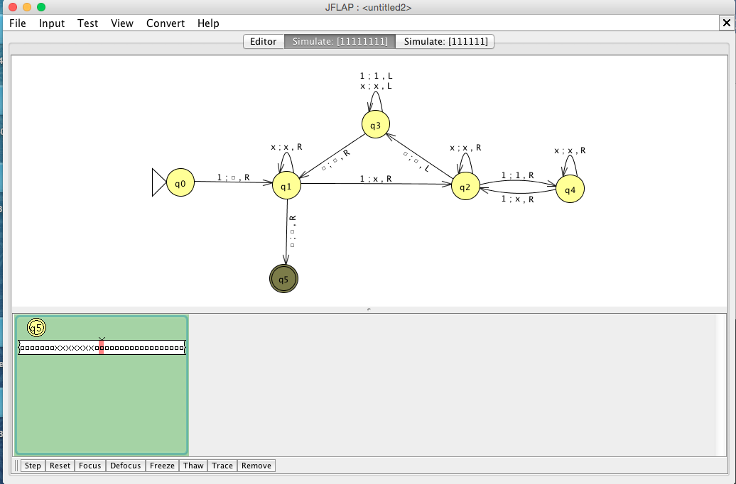

Reject 6 1’s

