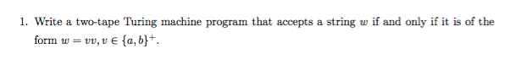

Consider a Turing machine with 2 tapes, T1 and T2, one of the tapes holds the initial input string, for example:

TM1 has the following two tapes:

|  |  |  |  |  |  |  |  |  |  |
| --- | --- | --- | --- | --- | --- | --- | --- | --- | --- |
| Tape1 | ▨ | a | b | a | b | ▨ | ▨ | ▨ | ▨ |
| Tape2 | ▨ | a | b | a | b | ▨ | ▨ | ▨ | ▨ |

We know that T1 in order to be accepted the word must be perfectly symmetric, so there must be an even number of letters in the word. If we load up the word into Tape1 and load up the same word into Tape2 and move the pointer twice as we transition through Tape­1 and once every time we transition through Tape2 we can determine if our string is even. Then by backtracking we can determine if our string is identical based on our pointer locations.