[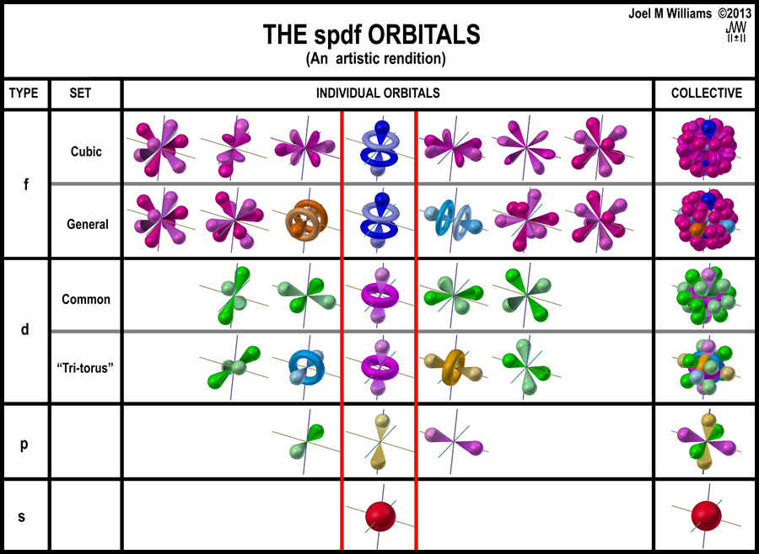](http://pages.swcp.com/~jmw-mcw/Parsing%20the%20spdf%20electron%20orbital%20model.htm)

Taken from http://www.art-aglow-new-mexico.com/a_chart_of_the_spdf_electron_orbitals.htm