**Effect of Pressure on the Solubility of Gases: Henry’s Law**

External pressure has very little effect on the solubility of liquids and solids. In contrast, the solubility of gases increases as the partial pressure of the gas above a solution increases. Because the concentration of molecules in the gas phase increases with increasing pressure, the concentration of dissolved gas molecules in the solution at equilibrium is also higher at higher pressures.

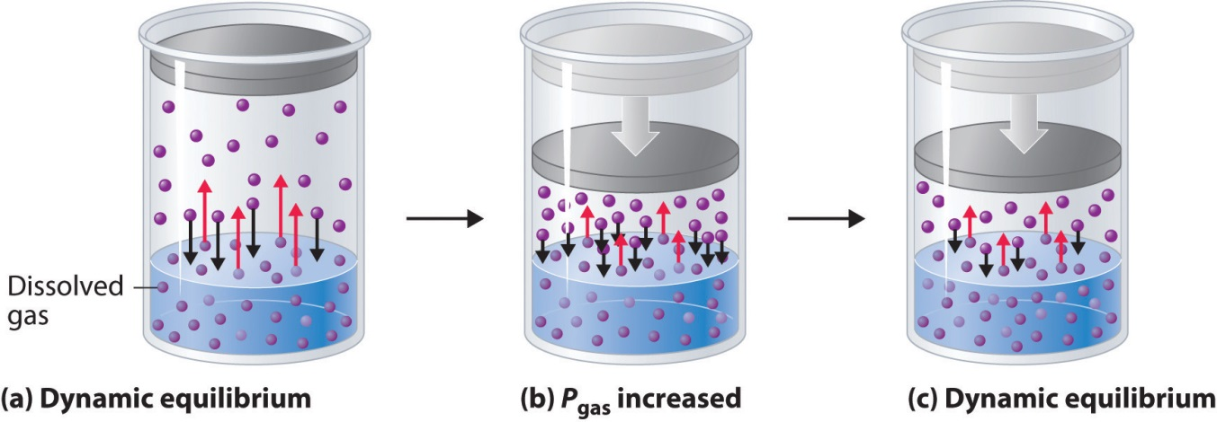

Figure 13.12: A Model Depicting Why the Solubility of a Gas Increases as the Partial Pressure Increases at Constant Temperature.

(a) When a gas comes in contact with a pure liquid, some of the gas molecules (purple spheres) collide with the surface of the liquid and dissolve. When the concentration of dissolved gas molecules has increased so that the rate at which gas molecules escape into the gas phase is the same as the rate at which they dissolve, a dynamic equilibrium has been established, as depicted here. This equilibrium is entirely analogous to the one that maintains the vapor pressure of a liquid.

(b) Increasing the pressure of the gas increases the number of molecules of gas per unit volume, which increases the rate at which gas molecules collide with the surface of the liquid and dissolve.

(c) As additional gas molecules dissolve at the higher pressure, the concentration of dissolved gas increases until a new dynamic equilibrium is established.