Harmonic vs. Morse Potential Energy

[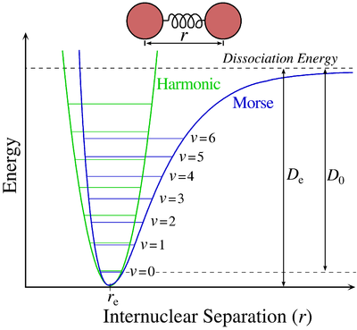](http://en.wikipedia.org/wiki/File:Morse-potential.png)

The **Morse potential** (blue) and **harmonic oscillator potential (green).** Unlike the energy levels of the harmonic oscillator potential, which are evenly spaced by ħω, the Morse potential level spacing decreases as the energy approaches the dissociation energy. The dissociation energy *D*e is larger than the true energy required for dissociation *D*0 due to the zero point energy of the lowest (*v* = 0) vibrational level.

The Morse potential energy function is of the form



Here  is the distance between the atoms,  is the equilibrium bond distance,  is the well depth (defined relative to the dissociated atoms), and  controls the 'width' of the potential (the smaller  is, the larger the well). The [dissociation energy](http://en.wikipedia.org/wiki/Bond_dissociation_energy) of the bond can be calculated by subtracting the [zero point energy](http://en.wikipedia.org/wiki/Zero_point_energy)  from the depth of the well. The [force constant](http://en.wikipedia.org/wiki/Force_constant) of the bond can be found by Taylor expansion of  around  to the second [derivative](http://en.wikipedia.org/wiki/Derivative) of the potential energy function, from which it can be shown that the parameter, , is



where  is the force constant at the minimum of the well.

Since the [zero of potential energy is arbitrary](http://en.wikipedia.org/wiki/Potential_energy#Relation_between_potential_energy_and_force), the equation for the Morse potential can be rewritten any number of ways by adding or subtracting a constant value. When it is used to model the atom-surface interaction, the energy zero can be redefined so that the Morse potential becomes

 which is usually written as



where  is now the coordinate perpendicular to the surface. This form approaches zero at infinite  and equals  at its minimum, i.e. . It clearly shows that the Morse potential is the combination of a short-range repulsion term (the former) and a long-range attractive term (the latter), analogous to the [Lennard-Jones potential](http://en.wikipedia.org/wiki/Lennard-Jones_potential).

**Vibrational states and energies**

Like the [quantum harmonic oscillator](http://en.wikipedia.org/wiki/Quantum_harmonic_oscillator), the energies and eigenstates of the Morse potential can be found using operator methods.[1] One approach involves applying the [factorization method](http://en.wikipedia.org/w/index.php?title=Factorization_method&action=edit&redlink=1) to the Hamiltonian.

To write the [stationary states](http://en.wikipedia.org/wiki/Stationary_state) on the Morse potential, i.e. solutions  and  of the following [Schrödinger equation](http://en.wikipedia.org/wiki/Schr%C3%B6dinger_equation):



it is convenient to introduce the new variables:



Then, the [Schrödinger equation](http://en.wikipedia.org/wiki/Schr%C3%B6dinger_equation) takes the simple form:





Its [eigenvalues](http://en.wikipedia.org/wiki/Eigenvalue) and [eigenstates](http://en.wikipedia.org/wiki/Eigenstate) can be written as:





where 

and  is the Laguerre Polynomial



There also exists the following important analytical expression for [matrix](http://en.wikipedia.org/wiki/Matrix_(mathematics)) elements of the coordinate operator (here it is assumed that  and )



The eigenenergies in the initial variables have form:



where  is the vibrational quantum number, and  has units of frequency, and is mathematically related to the particle mass, , and the Morse constants via



Whereas the energy spacing between vibrational levels in the [quantum harmonic oscillator](http://en.wikipedia.org/wiki/Quantum_harmonic_oscillator) is constant at , the energy between adjacent levels decreases with increasing  in the Morse oscillator. Mathematically, the spacing of Morse levels is



This trend matches the anharmonicity found in real molecules. However, this equation fails above some value of  where  is calculated to be zero or negative. Specifically,

