**Phase Transitions As A Metaphor for the Genesis of Complexity**

[[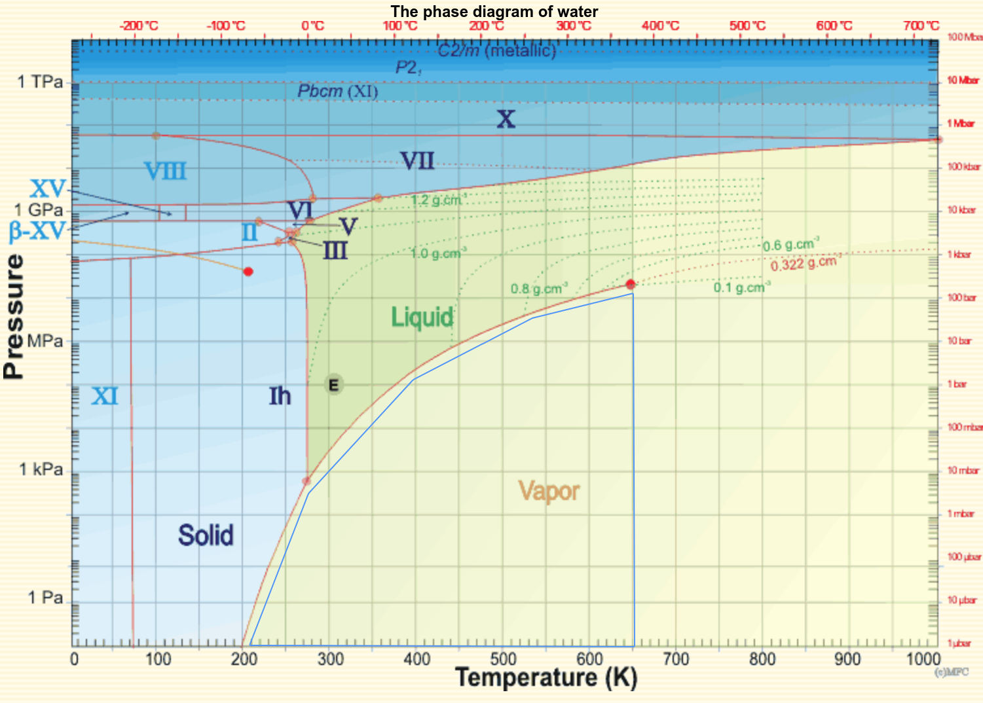](http://www.lsbu.ac.uk/water/phase.html)](http://www.lsbu.ac.uk/water/phase.html)  
  
From the website [Water Structure and Science](http://www1.lsbu.ac.uk/water/water_phase_diagram.html) by Martin Chaplin.