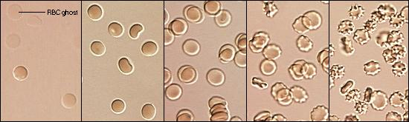

http://arbl.cvmbs.colostate.edu/hbooks/cmb/cells/pmemb/rbclabel.gif

Definition: A ***1.00 OsMolar (Os) Solution*** is one that contains 1 mole of solute ION/molecule per Liter of water

**Saline Solution** ~ 0.15M NaCl == 0.85% Salt Solution

0.300M total ion concentration = 300mM == **300mOs**