**Spectrophotometric Determination of Iron by Standard Additions**

Spectrophotometry is simply any technique that uses light to measure chemical concentrations. The utilization of spectrophotometry as a quantitative technique relies heavily on the Beer-Lambert Law or simply Beer’s Law which is given by , where A is absorbance, ε (epsilon) is molar absorptivity (or extinction coefficient) with unit of M-1 cm-1, b is the path length in cm, and c is the sample concentration in moles per liter. Note that absorbance is dimensionless. As may sometimes be seen, transmittance may be used instead of absorbance. Absorbance is defined as  where T is transmittance and  (or the fraction of the original light that passes through the sample).

Molecules may absorb different wavelengths of light as a result of the present structural features. Thus in a spectrophotometric analysis, it is important to select the wavelength that will result in the most intense signal. This is commonly referred to as lambda max (λmax). The selection of this particular wavelength ensures that the molecule is absorbing the greatest amount of light possible leading to a more sensitive analysis.

The wavelength chosen for this analysis is based on the fact that colors absorb opposite them in the color wheel. The color of the prepared samples is orange-ish, so it is likely that λmax is in the region of blue wavelengths. For this complex, λmax is found to be around 510 nm.

* 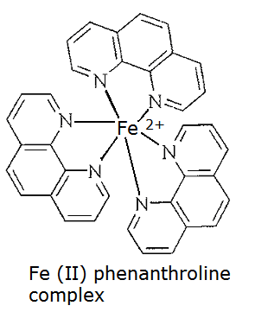**Violet:**   400 - 420 nm
* 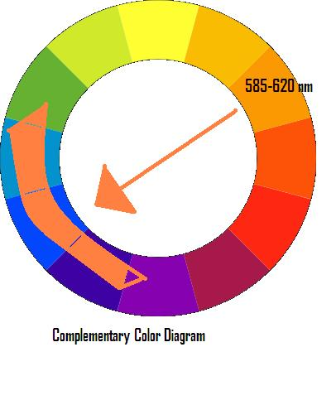**Indigo:**   420 - 440 nm
* **Blue:**   440 - 490 nm
* **Green:**   490 - 570 nm
* **Yellow:**   570 - 585 nm
* **Orange:**   585 - 620 nm
* **Red:**   620 - 780 nm

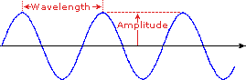 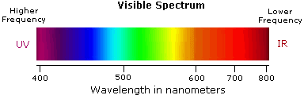

For this lab, the method of standard addition will also be used. Standard addition is the addition of known quantities of analyte to the unknown and is commonly used when there is the potential for matrix effects from the sample. As the concentration of the analyte increases, an increase in signal should be observed. From the resulting data, a few simple data manipulations (calculations and graphing) can be done to determine the concentration of the original sample.

You will prepare an unknown sample with no spike and then five (5) additional spiked samples. The spike volume will be in 50 µL increments to be delivered using a micropipette.

**Preparing your samples**

1. Appropriately label your volumetric flasks to indicate 0, 1, 2, 3, and 4 spikes.
2. Obtain an unknown and add 15 mL to each of five (5) 25 mL volumetric flasks.
3. To the 1 spike volumetric flask add 50 µL of the approximately 0.018 M iron stock solution. Be sure to record the exact concentration of the iron stock solution. To the 2 spike volumetric flask add two 50 µL spikes of the iron stock solution to the volumetric flask. Continue this process with all volumetric flasks adding the appropriate number of spikes to the corresponding volumetric flasks.
4. To all five volumetric flasks add the following **in the order listed**:
   1. 2.5 mL hydroxylamine hydrochloride (reducing agent)
   2. 2**.**5 mL sodium acetate solution (slightly basic)
   3. 2**.**5 mL orthophenanthroline (Complexing agent)
5. Finally bring the samples up to 25 mL by adding DI water to the mark on the volumetric flask.
6. To a sixth volumetric flask add the three solutions listed above and dilute to the 25 mL mark using DI water. This will serve as your blank sample.

**Analyzing your samples**

1. Set the spectrophotometer to analyze using a wavelength of 510 nm. Fill a cuvette at least half full with the blank solution, wipe it off with a kimwipe, and place it in the cell compartment. Set the absorbance to zero. Remove the cuvette and discard of the solution.
2. Next, using the same cuvette, fill it with the LEAST concentrated solution (this solution will be the lightest orange color), and rinse the cuvette into a waste beaker. Then refill with this same solution and place the cuvette into the cell compartment, and close the cover. Record the absorbance.
3. Continue to analyze the remaining samples using this same procedure. Remember to always analyze samples from lowest to highest concentration. Also, always fill the cuvette with sample and then rinse the solution into a waste beaker before filling with sample that will be read on the spectrophotometer.

The resulting data should allow you to find the concentration of the original sample either through graphical means or through other calculations. You may choose which method to use. **Be sure to account for all dilutions done to samples.**