**TWO NON EQUIVALENT p-ORBITAL ELECTRONS (np, mp)**

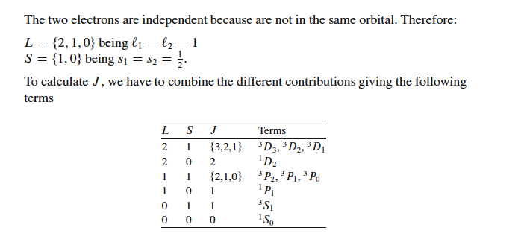

**TWO EQUIVALENT p-ORBITAL ELECTRONS (np2)**

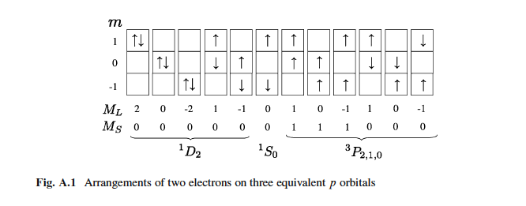

Note: 3D not allowed since no ML=2, MS=1

1P not allowed since no ML=1, MS=0 left after 3P

3S not allowed since no ML=0, MS=1 left after 3P

**CARBON GROUND STATE 1s2 2s2 2p2**

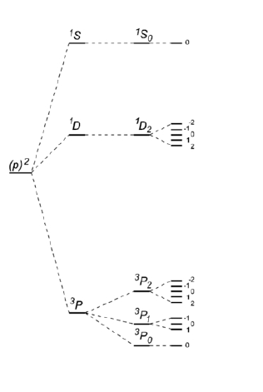

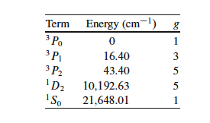

**THREE(3) NON EQUIVALENT p-ORBITAL ELECTRONS (np, mp op)**

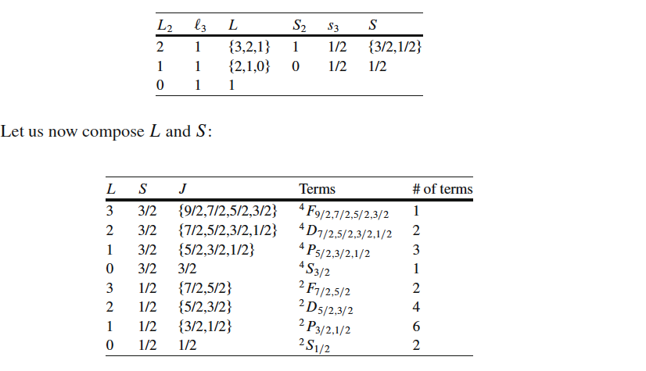

**THREE(3) EQUIVALENT p-ORBITAL ELECTRONS (np3)**

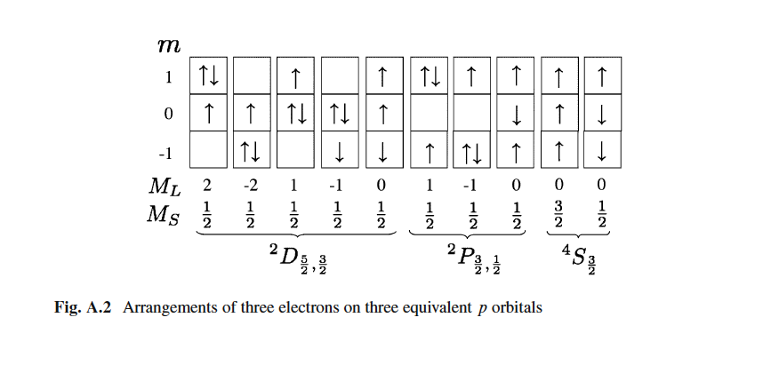

**NITROGEN GROUND STATE**

