**Determination of Vitamin C by Redox Titration**

**Introduction**

Most mammals can synthesize vitamin C, or ascorbic acid (C6H8O6) from sugars. Yet humans ingest considerable quantities. The National Academy of Sciences recommends the consumption of 60 mg of ascorbic acid per day. Vitamin C deficiencies can cause abnormalities in bones and teeth as first observed in sailors in the eighteenth century. Many vegetables contain large quantities of vitamin C, but it is often destroyed in foods by many cooking processes. Thus citrus fruits are generally a more reliable source of vitamin C.

The determination of vitamin C can be done by an oxidation-reduction titration utilizing iodine. Iodine is a very versatile redox reagent as its potential falls in the middle of the range of potentials observed in aqueous solutions. As a result, in the presence of strong oxidants, such as dichromate, iodide is oxidized to iodine; in the presence of reducing agents, such as As (III), iodine is reduced to iodide. Solid I2 is only slightly soluble in water, but in the presence of excess iodide it forms the **soluble triiodide anion, I3-.** It is this form that is used in the redox titrations.

**I2(aq) + I- 🡺 I3-**

An advantage to a titration utilizing I3- is the availability of the “starch indicator”. I3- reacts with the starch to form an intense blue color that is visible even at very low I3- concentrations. The endpoint of the titration can be determined either by the disappearance or the appearance of this intense blue color, depending on what the titrant is. Care must be taken, though, to add the starch after most of the I3- has already reacted. In the presence of large I3- concentrations a rather stable complex forms, and the blue color may persist beyond the equivalence point.

In this titration you will be utilizing a standardized I3- solution to determine the concentration of an unknown ascorbic acid solution. While the I3- solution is often standardized using a thiosulfate solution, a standard vitamin C solution will be used for simplicity. Thus what is observed in the standardization is what will be observed in the determination of the unknown as well. The triiodide solution reacts with the ascorbic acid by oxidizing it to dehydroascorbic acid.

**C6H8O6 + I3- 🡪 C6H6O6 + 3 I- +2 H+** IO3-+ 6 H+ + 8 I- 🡺 3 I3- + 3 H2O

**Vitamin C dehydroascorbic acid**

[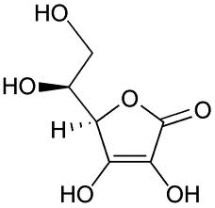](http://www.google.com/imgres?q=vitamin+c&hl=en&sa=X&qscrl=1&nord=1&rlz=1T4ADSA_enUS406US435&biw=1024&bih=574&tbm=isch&tbnid=2WcjDBpbwXYgRM:&imgrefurl=http://en.wikipedia.org/wiki/File:Ascorbic_acid_structure.png&docid=E8QDcuIBkBljrM&imgurl=http://upload.wikimedia.org/wikipedia/commons/8/81/Ascorbic_acid_structure.png&w=621&h=600&ei=ua9wT8bCNoKasgLTm830BQ&zoom=1) oxidized to 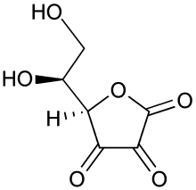 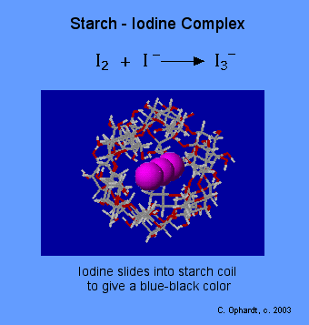

**Preparation of Iodine Solution**

Dissolve 5**.**0 grams potassium iodide (KI) and 0**.**268 g potassium iodate (KIO3) in about 300 mL of ultrapure water in a 500 mL volumetric flask. When the solid is dissolved completely, add 6 mL concentrated (18 M) sulfuric acid (H2SO4). Mix well and dilute up to a final volume of 500 mL.

**Standardization of the Iodine Solution with a Standard Vitamin C Solution**

Using a 25 mL volumetric pipet, add 25 mL of the standard Vitamin C solution into an Erlenmeyer flask. Add 20 drops of 1% starch solution to the Erlenmeyer flask with the Vitamin C. Rinse the burette with 5-10 mL of iodine solution, and then fill it. Record the initial buret volume. Titrate the Vitamin C solution until the presence of a blue color is persistent. Repeat at least two additional times or until the precision is acceptable. Determine the concentration of the I3**-** solution.

**Titration of an Unknown Vitamin C Solution**

Obtain a Vitamin C solution and record the unknown. Titrate as previously done in the standardization performing at least 3 titrations or until precision is acceptable. Determine the concentration of the unknown Vitamin C solution.