**Determination of Vitamin C by Redox Titration**

**Introduction**

Most mammals can synthesize vitamin C, or ascorbic acid (C6H8O6) from sugars. Yet humans ingest considerable quantities. The National Academy of Sciences recommends consumption of 60 mg of ascorbic acid per day. Vitamin C deficiencies can cause abnormalities in bones and teeth as first observed in sailors in the eighteenth century. Many vegetables contain large quantities of vitamin C, but it is often destroyed in foods by many cooking processes. Thus, citrus fruits are generally a more reliable source of vitamin C.

The determination of vitamin C can be completed via an oxidation-reduction titration utilizing iodine. Iodine is a very versatile redox reagent as its potential falls in the middle of the range of potentials observed in aqueous solutions. As a result, in the presence of strong oxidants, such as dichromate, iodide is oxidized to iodine; in the presence of reducing agents, such as As (III), iodine is reduced to iodide. Solid I2 is only *slightly* soluble in water, but in the presence of excess iodide it forms a soluble triiodide anion (I3- ). It is this form that is used in the redox titrations.

**I2  + I- 🡺 I3-**

An advantage to a titration utilizing the triiodide anion is the use of “starch indicator.” I3- reacts with the starch indicator to form an intense blue color, visible even at very low concentrations of I3-. The endpoint of the titration can be determined by either the disappearance or the appearance of this intense blue color, depending on what the titrant is. In the presence of large I3 - concentrations a rather stable complex forms with starch and the blue color may persist beyond the equivalence point. So a different titration technique must be employed (either 180° stopcock turns OR steady ‘drip’ pace). Do not simply open the stopcock and let the titrant flow. Titrant must be added slowly to ensure accurate results [avoid a false-positive endpoint].

In this experiment, a solution of I3 – *which must be prepared & then standardized* is used to determine the concentration of ascorbic acid in an unknown solution. While the I3 - solution is often standardized using a thiosulfate solution, in this experiment a standard vitamin C solution is used for convenience. Thus, what is observed during the standardization is what will be observed in the determination of the unknown as well (i.e. the endpoint color is consistent).

The triiodide solution reacts with ascorbic acid by oxidizing it to dehydroascorbic acid:

**C6H8O6 + I3- 🡪 C6H6O6 + 3 I- + 2 H+**

**Vitamin C dehydroascorbic acid**

[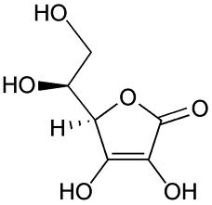](http://www.google.com/imgres?q=vitamin+c&hl=en&sa=X&qscrl=1&nord=1&rlz=1T4ADSA_enUS406US435&biw=1024&bih=574&tbm=isch&tbnid=2WcjDBpbwXYgRM:&imgrefurl=http://en.wikipedia.org/wiki/File:Ascorbic_acid_structure.png&docid=E8QDcuIBkBljrM&imgurl=http://upload.wikimedia.org/wikipedia/commons/8/81/Ascorbic_acid_structure.png&w=621&h=600&ei=ua9wT8bCNoKasgLTm830BQ&zoom=1) **oxidized to** 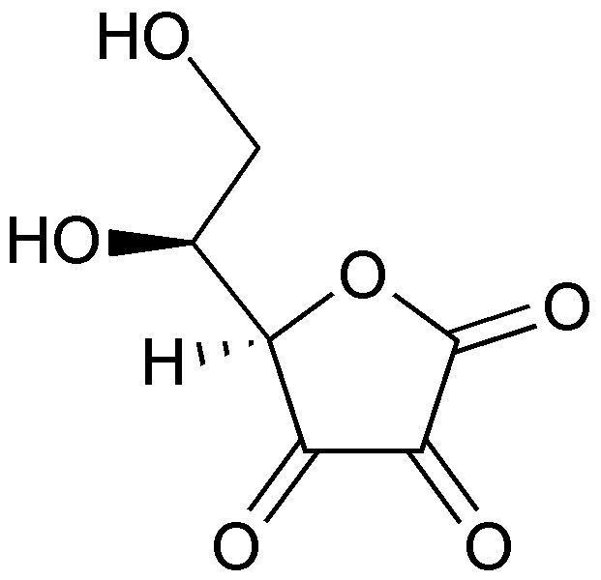

**Preparation of Iodine Solution**

Dissolve ~5**.**000 grams of potassium iodide (KI) and ~0**.**2680 grams of potassium iodate (KIO3) in about 300 mL of Nanopure H2O in a 500.0 mL volumetric flask. After the solids dissolve completely, add ~6.0 mL of concentrated (18.0 M) sulfuric acid (H2SO4) using a 10.0 mL graduate cylinder. [Acid *must* stay in the fume hood, bring your flask to the fume hood]. The color of the solution in the flask should be a dark amber/brown after the addition of H2SO4. Dilute the flask to volume with Nanopure H2O. Parafilm, invert flask to mix. Keep the volumetric flask Parafilm-ed until use. If iodine solution is transferred to a beaker, cover with a watchglass.

The following is the reaction of formation of the triiodide ion needed for this experiment:

IO3- + 6 H+ + 8 I- 🡺 3 I3- + 3 H2O

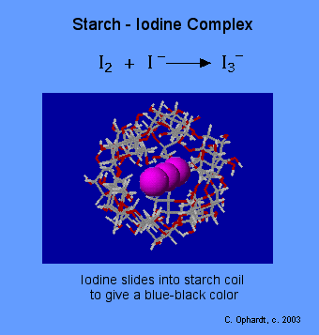

**Standardization of the Iodine Solution with a Standard Vitamin C Solution**

Using a 25.00 mL volumetric pipet & pipet bulb, transfer 25.00 mL of the standard Vitamin C solution to a clean 250 mL Erlenmeyer flask. Then, add 20 drops of 1% starch indicator. Rinse a buret with 5-10 mL of iodine solution. Discard rinse and then completely fill the buret with iodine solution (remember to fill the buret tip). Titrate the Vitamin C solution until the presence of a blue color is persistent for at least 30 seconds. Complete at least 3 titrations. Determine the concentration [molarity] of the I3 - solution. Calculate average, standard deviation, and parts per thousand (ppt) to ensure precision is acceptable.

**Titration of an Unknown Vitamin C Solution**

Obtain an aqueous unknown Vitamin C solution. Rinse the 25.00 mL volumetric pipet with Nanopure water; then rinse with the unknown solution! Transfer 25.00 mL of the unknown solution to a clean 250 mL Erlenmeyer flask. Add 20 drops of 1% starch indicator. Titrate the Vitamin C solution until the presence of a blue color persists for at least 30 seconds. Complete at least 3 titrations. If precision is poor (> 5ppt), complete additional titrations of the unknown vitamin C solution. Determine the concentration [molarity] of the unknown Vitamin C solution. Calculate average, standard deviation, and ppt. The unknown solutions range from 0.008000 - 0.01200 M of vitamin C.