**Titration of a Polyprotic Acid with a Strong Base Using a pH Meter**

**Background**

Monitoring a titration’s endpoint can be achieved through adding an indicator to a reaction mixture, thereby looking for a visual change in color of the mixture during titration. An endpoint can also be determined through use of a pH meter during titration. This experiment will focus on the latter. Note the difference between the following terms: *equivalence point* and *endpoint.* The former is based on the stoichiometry of the balanced molecular equation [reaction], while the latter is a measurement of change in a physical property during a titration. The end point is measured to infer where the equivalence point of a reaction lies.

In some instances, simple colorimetric methods may not suffice in determining an end point of a titration. In this experiment, the construction of a pH titration curve and further graphical analyses facilitates the determination of a titration’s end point, as well as, both the identity and concentration of an unknown acid solution.

The principles used for titration of a *monoprotic acids and bases* readily extend to titration of *polyprotic acid and bases*. Recall that a monoprotic acid has one acidic proton, while polyprotic acids have more than one proton that is acidic.

A ***monoprotic acid, HA,*** has a single equivalence point. This acid is represented by the general equation:

***HA(aq) + OH-(aq) 🡪 H2O(aq) + A-(aq)***

The above equation is the strong acid dissociation seen in several lab experiments already. The titration curve of a strong acid titration reveals a single buffer region, equivalence point, and pKa.

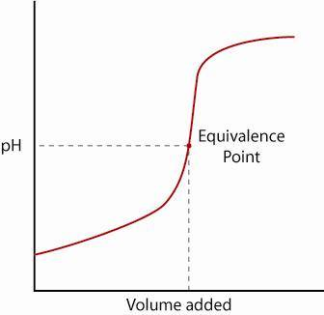

***Diprotic acids, H2A,*** add another dimension to the analysis. A generalized equation is:

***H2A(aq) + 2OH-(aq) 🡪 2H2O(aq) + A2-(aq)***

This equation can also be written as two separate dissociations for each acidic proton:

***H2A(aq) + OH-(aq)* ⬄ *H2O(aq) + HA-(aq)*** followed by ***HA-(aq) + OH-(aq)* ⬄ *H2O(aq) + A2-(aq)***

The titration curve of a diprotic acid shows two buffer regions, equivalence points, and pKa values:

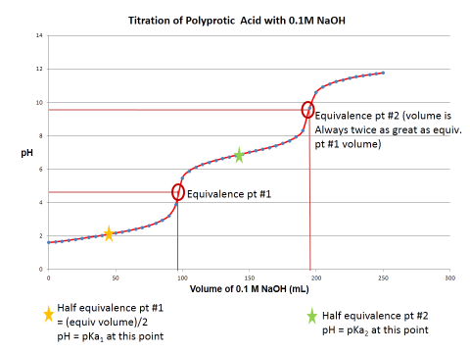

Characteristic to all acids is the pKa value for each acidic proton. Recall that pKa = -log(Ka), where Ka is the acid dissociation constant. Graphical manipulation of the titration curve allows for the determination of pKa values, thus the identity of the acid, as well as information to calculate the acid’s concentration.

A titration curve (pH versus volume of titrant) can be manipulated by calculating first and second derivative graphs. These graphs give confirmation of the end points of the titration by representing them in a clearer manner. For a first derivative graph, the maxima represent the equivalence point volume. In the second derivative graph, the equivalence point volume can be determined by where the graph crosses the x-axis. What can be further observed are basic mathematical relations between the equivalence points and pKas. With all of this information combined, it is possible to determine the identity and concentration of an unknown acid solution.

During this experiment, two pH titration curves will be constructed with the ultimate purpose of 1) identifying the unknown polyprotic acid [based on the experimentally determined pKa values in comparison to a list of possible acids & corresponding pKa values] and 2) quantifying the acid’s molarity.

The first titration curve will serve as a “quick and dirty” titration allowing the experimenter a rough estimate of where the equivalence points are. When generating the second titration curve, more data points are needed therefore in the second attempt of this curve’s construction much more careful titration technique is required!

**Procedure**

1. Prepare 1 L of ~0.1 M sodium hydroxide, NaOH* and standardize it using 0.7-0.8 grams primary standard grade potassium hydrogen phthalate, KHP (same procedure as completed in lab #1). *If enough NaOH remains from lab #1, use it (perhaps confirm its standardized concentration).
2. Obtain a pH meter. If necessary, calibrate it using pH 4 and pH 7 buffer solutions. Rinse the electrode with Nanopure H2O, gently dab with a Kimwipe, and then place it into a small beaker containing buffer of pH 7; adjust the meter with a screwdriver so the reading is 7.00. Rinse the pH meter with Nanopure H2O, dab the bulb with a Kimwipe, and place in pH 4 buffer. Adjust pH meter to 4.00. Calibration is complete. Rinse the pH meter before placing it into any other solutions. Always store pH meter in a beaker of H2O when it is not in use during the experiment.
3. Obtain an aqueous unknown polyprotic acid solution in a brown bottle. The first titration is a rough estimate of the end point. Using a volumetric pipet & pipet bulb, transfer 25.00 mL of the unknown acid solution into a 250 mL beaker. Add a magnetic stir bar. Place the beaker on a magnetic stir plate (slow stirring). Use a micro-clamp to position the pH meter so that the bulb is submerged in the unknown solution but it does not touch the sides of the beaker or the stir bar.
4. Prepare a buret using good laboratory technique. Titrate the unknown acid by adding the standardized NaOH solution in 1.00 mL aliquots via a buret. Record the pH and buret reading after *each* volume addition of NaOH! Continue the titration until the pH of the solution is at or near 12.
5. Based on the pH titration curve [generate via Excel], estimate the equivalence point volume(s) to within 0.50 mL.
6. IF first titration curve looks adequate (confirm with Instructor or TA), steps #6 and #7 are optional [to generate more data around the equivalence points]. Complete the titration again *carefully*! Pipet 25.00 mL of unknown acid solution into a 250 mL beaker. Add a magnetic stir bar and place the beaker on a magnetic stir plate (slow stirring). Re-clamp the pH meter so the bulb is submerged in solution but so it does not touch the sides of the beaker or the stir bar.
7. Start the titration as previously done by adding 1.00 mL aliquots of NaOH titrant, recording the exact total volume of titrant added AND pH of the solution after each addition. **Slow down the titrant volume addition when you are within 2-5 mL of the estimated equivalence volume(s). Switch to adding titrant in 0.2 mL increments.** Continue recording the volume added and the solution’s pH. Once each equivalence point is passed, revert back to 1.00 mL NaOH increments.
8. Continue the titration until pH of the solution is at or near 12.

**ALWAYS RECORD THE TOTAL VOLUME OF TITRANT ADDED EACH TIME YOU RECORD THE pH VALUE.**

***See the next page for important information on how to generate 1st and 2nd derivative graphs.***

**Data Analysis for Weak Acid-Strong Base pH Titration Curve:**

1. Construct a graph of pH (y-axis) versus volume [mL] of NaOH (x-axis).
2. Following the example in Table 10-3 and Figure 10-4 of the lecture textbook, compute the first derivative (this is the slope of the titration curve points). Graph (∆pH/∆volume) on the y-axis, and volume [mL] of NaOH on the x-axis. Estimate the equivalence point volume(s) from this derivative graph, which are represented as the peaks of the 1st derivative graph.
3. Following the example in Table 10-3, compute the second derivative (the slope of the slope). Graph ∆(∆pH/∆volume)/∆volume on the y-axis and volume [mL] of NaOH on the x-axis. Locate the equivalence point volume(s) on the 2nd derivative graph. For the second derivative, the equivalence volume is the point where the line crosses the x-axis.
4. All three graphs should have a proper title, axes labels, and any other identifying information such as circling the equivalence points, starring half equivalence to i.d. pKa values , etc.
5. Use the table below of possible unknown acids. Find the experimental pKa values, determined from the titration curve, and use them to assist in identifying the name of the unknown acid.
6. Then use the equivalence point volume [first or second equivalence volume will work] to determine the concentration of the unknown acid solution.

Do consult the lecture text, Harris, D. Exploring Chemical Analysis, as it discusses pH titration curves and both 1st, 2nd derivative graphs.

**Possible Unknown Acids:**

|  |  |  |  |  |  |
| --- | --- | --- | --- | --- | --- |
| **Name** | **Formula** | **Molecular Weight (g/mol)** | **pKa1** | **pKa2** | **Structure** |
| Oxalic Acid  (ethanedioic acid) | H2C2O4 | 90.03 | 1.25 | 4.27 |  |
| Malonic Acid  (propanedioic acid) | H4C3O4 | 104.06 | 2.85 | 5.70 |  |
| Maleic Acid  (*cis-*butenedioic acid) | C4H4O4 | 116.07 | 1.92 | 6.27 |  |
| Succinic Acid  (butanedioic acid) | C4H6O4 | 118.09 | 4.21 | 5.64 |  |
| Malic Acid  (hydroxybutanedioic acid) | C4H6O5 | 134.09 | 3.40 | 5.20 |  |
| Tartaric Acid  (2,3-dihydroxybutanedioic acid) | C4H6O6 | 150.09 | 3.04 | 4.37 |  |