**What is Temperature?**

**Temperature is a special average (RMS-average) of the Translation Energies of Molecules.**

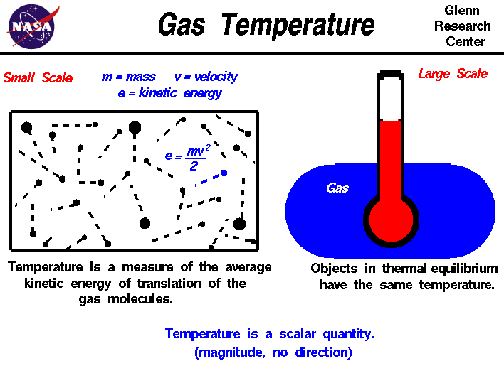

**This average is based upon a distribution called the Boltzmann Distribution**

