Definitions and Convention
Signs The sign of energy, work and heat imparted on or extracted
from the system simply depends on convention. Since, Engineers,
Chemist and Physicist often use different conventions therefore a fundamental
understanding is essential. Consider a bounded system.
- Fetter’s convention defines all energy added to the system (E) in the form of heat (Q) added or work done (W) on the system to be positive.
- Reif defines the work (W) done by the system a positive quantity.
However he does define a script (W) that positive for work done on the system.

Integrals are always evaluated
Z final state
initial state

An exact differential or perfect differential is path independent and denoted by d

An inexact differential or imperfect differential is dependent on he path of integration and is denoted by d

Irreversible: If the final situation is such that the imposition or removal of constrains of this isolated system cannot restore the initial situation, then the process is irreversible.

Reversible: If imposing or removing some constraints on the system enables it to restore it to it initial situation, the process is reversible.

States
A key concept in thermodynamics is the state of a system. A state consists of all the information needed to completely describe a system at an instant of time. When a system is at equilibrium under a given set of conditions, it is said to be in a definite state. For a given thermodynamic state, many of the system's properties (such as T, V, p, and ) have a specific value corresponding to that state. The values of these properties are a function of the state of the system. The number of properties that must be specified to describe the state of a given system (the number of degree of freedom) is given by Gibbs phase rule:
f = c - p + 2
f is the number of degrees of freedom, c is the number of components in the system, and p is the number of phases in the system. Components denote the different kind of species in the system. Phase means a system with uniform chemical composition and physical properties.
For a one component system:
A state requires 3 independent variable (2 intensive & always one extensive {usually #moles) and can thus be defined as :
f(a,b,c) =0 for example PV - RT = 0 where V is molar volume(extensive variable)
where a,b,c are independent physical properties and at least one is extensive
Closed System - It exchanges energy (heat and work) but not matter with the environment. A greenhouse is an example of a closed system exchanging heat but not work with its environment. Another example is the heat engine shown in Figure 03. It is defined as a device that converts heat energy into mechanical energy or more exactly a system which
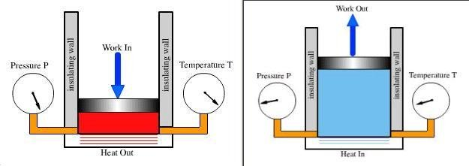
Isolated System - It does not exchange heat, matter or work with the environment. An example of an isolated system would be an insulated container, such as an insulated gas cylinder. In reality, a system can never be absolutely isolated from its environment, because there is always at least some slight coupling, even if only via minimal gravitational attraction
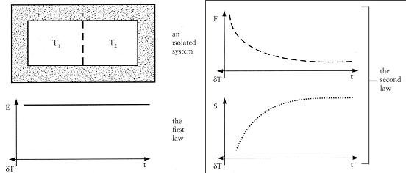

Open System - It exchanges energy (heat and work) and matter with the environment. A boundary allowing matter exchange is called permeable. It's possible for an open system to import order and export disorder, locally increasing order. What the Second Law says is that in such a transaction more disorder than order will be created. It does not, however, forbid the creation of pockets of order. What happens is that disorder in the entire system will increase even though individual open systems within it might become more ordered.
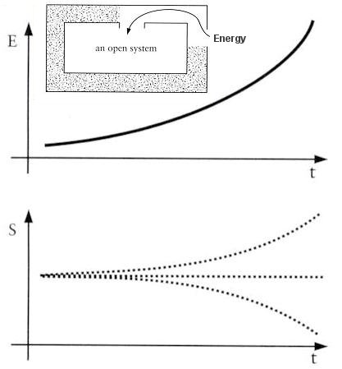

Thermodynamic Process
Thermodynamic process is a way of changing one or more of the properties in a system resulting in a change of the state of the system. The following summarizes some of the more common processes:
- Adiabatic Process - This is a process that takes place in such a manner that no heat enters or leaves a system.
- Isochoric Process - If a system undergoes a change in which the volume remains constant, the process is called isochoric.
- Isobaric Process - A process taking place at constant pressure is call an isobaric process.
- Isothermal Process - Isothermal process changes the system slowly so that there is enough time for heat flow to maintain a constant temperature.

Slow change is a reversible process, because at any instant the system is in its most probable configuration. In general, a process will be reversible if:
it is performed quasistatically (slowly);
it is not accompanied by dissipative effects, such as turbulence, friction, or electrical resistance.
- Isentropic Process - If the slow change is accomplished in an insulated container, there is no heat flow. Since S= dQ/T here is also no change in entropy. Thus, a reversible adiabatic process is isentropic.

- Heat (Q) is a form of energy transfer associated with random motion of the microscopic particles.
- Work (W) is the organized form of energy transfer associated with the motion of microscopic particles as a whole (in a certain direction), e.g., the expanding gas that propels a piston.
- Internal Energy - The internal energy (U) or (E) of a system is the total energy due to the motion of molecules, plus the rotation, and vibration of atoms within molecules. Heat and work are two methods of adding energy to or subtracting energy from a system. They represent energy in transit and are the terms used when energy is moving. Once the transfer of energy is over, the system is said to have undergone a change in internal energy dU. Thus, in terms of the amount of heat dQ and work dW:
dU = dE = dQ + dW

Rough Derivation of Kinetic Temperature

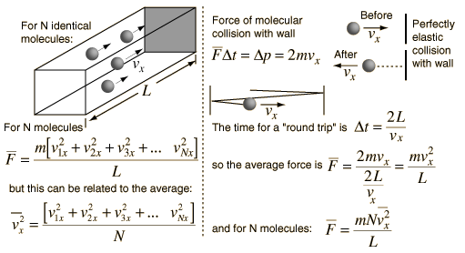
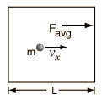 | 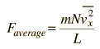  and assuming random speeds in all directions  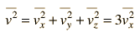  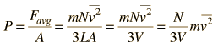
Expressed in terms of average molecular kinetic energy:
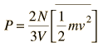
This leads to a concept of KINETIC TEMPERATURE
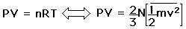
This leads to the expression
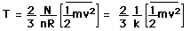
The more familiar form expresses the average molecular kinetic energy:
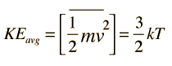
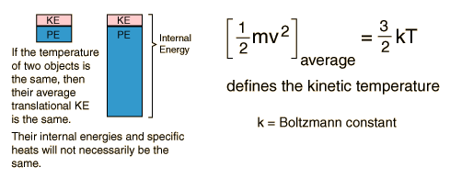

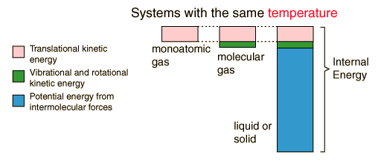

Comparison of temperature scales

Comment | Kelvin  K | Celsius  °C | Fahrenheit  °F | Rankine  °Ra (°R) | Delisle  °D ¹ | Newton  °N ¹ | Réaumur  °R (°Ré, °Re) ¹ | Rømer  °Rø (°R) ¹
Absolute zero | 0 | −273.15 | −459.67 | 0 | 559.72 | −90.14 | −218.52 | −135.90
Water freezes  (at standard pressure | 273.15 | 0 | 32 | 491.67 | 150 | 0 | 0 | 7.5
Water boils (at standard pressure) | 373.1339 | 99.9839 | 211.97102 | 671.64102 | 0 | 33 | 80 | 60

k= 1.380658(12) x 10⁻²³ J/K

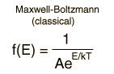 | 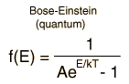 | 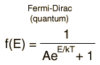

Maxwell-Boltzmann statistics
For the purpose of comparison, it is instructive to consider the purely classical case of Maxwell-Boltzmann statistics. The partition function is written
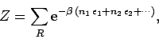

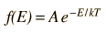
in one dimension, it becomes:
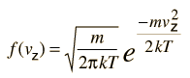
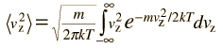
This integral can be put in the standard form:
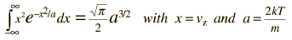
This gives:
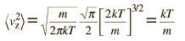

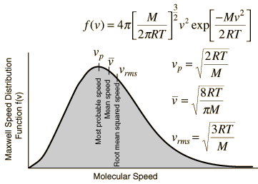

The average kinetic energy for one dimension is then
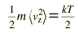
and for three dimensions of such motion the average kinetic energy is:
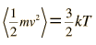

Two particles distributed amongst three states according to Maxwell-Boltzmann statistics. There are clearly 9 distinct states.
1 | 2 | 3

For the case of Bose-Einstein (BE) statistics, the two particles are considered to be indistinguishable. Let us denote them both as . Furthermore, any number of particles can occupy the same quantum state.
For the case of Bose-Einstein (BE) statistics, the two particles are considered to be indistinguishable. Let us denote them both as . Furthermore, any number of particles can occupy the same quantum state

Two particles distributed amongst three states according to Bose-Einstein statistics.
1 | 2 | 3

There are clearly 6 distinct states.
Finally, for the case of Fermi-Dirac (FD) statistics, the two particles are considered to be indistinguishable. Let us again denote them both as . Furthermore, no more than one particle can occupy a given quantum state.
Two particles distributed amongst three states according to Fermi-Dirac statistics.
1 | 2 | 3

