Acid-Base Titration: Determination of Potassium Hydrogen Phthalate and Unknown Sodium Carbonate

Solutions of the strong acids and bases, which are used as standard solutions in titrametric analysis, must be prepared approximately and the exact concentration is determined by titration with a primary standard material.

Prepare 0.1 M Hydrochloric Acid Solution
Calculate and add the correct amount of concentrated HCl to 1 liter of distilled water in the 1L volumetric flask then transfer it to the glass stoppered 1L storage bottle. Use the glass stoppered bottle so the rubber stoppered bottle may be used for NaOH. In this part you do not have to measure out conc. HCl precisely. Conc. HCl is 12 M. M₁V₁=M₂V₂ Students should avoid skin contact of conc. HCl and avoid inhaling its vapors. Transfer conc. HCl in the hood. Do not pipet by mouth. Always add acid to water.

Prepare 0.1 M Sodium Hydroxide Solution
Calculate and add the correct amount of NaOH to 1 liter of distilled water in the 1L volumetric flask then transfer to your rubber stoppered 1L flask. In this part you do not have to weigh NaOH precisely. Do not use the analytical balance. MW NaOH=40g/mole

Standardize Sodium Hydroxide against Potassium Hydrogen Phthalate (KHP)
Potassium Hydrogen Phthalate is a white, crystalline solid, which is suitable for use directly as a PRIMARY STANDARD. Before you use it, it is best to dry KHP for a few hours in an oven at 100ºC to remove traces of surface moisture (your TA will have already placed the unknown samples in the oven for you). It is then best stored in a desiccator.

KHC₈H₄O₄ + NaOH ➔ KNaC₈H₄O₄ + H₂O

where KHP = KHC₈H₄O₄

First Potassium Salt of Phthalic Acid (benzene-1,2-dicarboxylic acid)

Obtain a quantity of dried primary KHP in a weighing bottle and keep it stored in your desiccator. If you see the blue drierite has turned pink, it’s time to change the dreierite in your desiccator.

Weigh (by difference) separate 0.7-0.8 g samples (to the nearest 0.1mg i.e., 0.0001 g) into
a 250 mL Erlenmeyer flask, and dissolve in 50-75 mL distilled water. From now on, if a weight has (0.1 mg) behind it, weigh it on the analytical balance. Otherwise use the regular balance.
Add 2-3 drops phenolphthalein indicator and titrate with base to its endpoint. Calculate the concentration of the NaOH solution. Repeat the titration at least two more times and calculate relative deviation. Your results should be within 5 ppt. The ppt (parts per thousand) equation is found at the end of proper uses of lab equipment and equations.

moles of KHP (grams of KHP)/ (Molar Mass KHP)= M_{base} x V_{base}

M_{base =} moles_{KHP} / V_{base}

Determine Acid Concentration:

Deliver 25 ml of your acid using a 25 ml volumetric pipet or burette into a clean 250 mL Erlenmeyer flask and record the final volume reading. Add 2 or 3 drops of phenolphthalein indicator to the solution and begin to titrate base until a faint pink tint remains for at least 30 seconds. (A good indication of pink is that it is faint close by the flask, but seems clear on the other side of the room.) Record the final buret reading. Repeat the titration at least two more times and calculate relative deviation. Your results should be within 5 ppt.

Determine Percent Sodium Carbonate in an Impure Sample:

The percent sodium carbonate (also known as “soda ash”) can be determined by virtue of the very slight ionization of carbonic acid, which causes the displacement reaction below to go completely to the right.

Na₂CO₃ + 2 HCl ➔ H₂CO₃ + 2NaCl

where Carbonic Acid [H₂CO₃ == H₂O + CO₂(g)]

Prepare two solutions to use as color “standards” for the starting point and the endpoint. To 50 – 75 mL of distilled water in an Erlenmeyer flask, add 6-7 drops of methyl orange indicator. This solution will serve as a comparison for the starting point of the titration. For the second solution weigh out 0.2 gram (0.1 mg) of sodium carbonate and dissolve it in 50-75 mL of distilled water in an Erlenmeyer flask. Add 6-7 drops of methyl orange. Calculate how much of your standardized HCl solution is needed to bring the titration to its endpoint and carefully add this volume, using a burette, to the flask while swirling. This solution will serve as the reference for the end point of the titration.

Determine the appropriate amount of unknown needed to titrate using about 40 mL HCl. Weigh out the sample to the nearest 0.1 mg and place it into a 250 mL Erlenmeyer flask. Dissolve the unknown in 50 – 75 mL of distilled water. To the unknown add 6-7 drops of methyl orange indicator and carefully titrate with your standard HCl until the solution begins to JUST turn from yellow to faint orange.
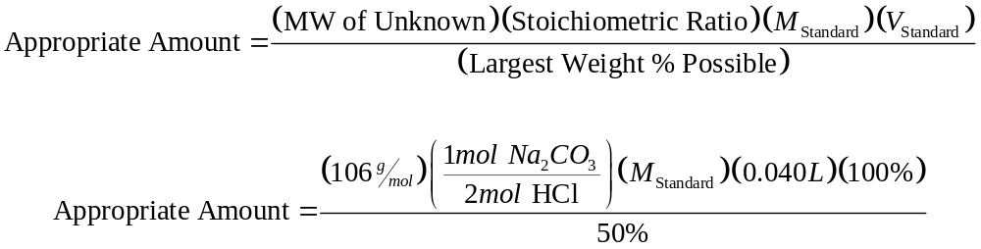
Calculate the new mass needed to titrate the unknown with about 40 mL of HCl. Repeat the titration at least two more times and calculate the percentage and relative deviation. The unknown percentages are in the range 20-50%.
