Arrhenius Acids and Bases
The Arrhenius definition of acids and bases is one of the oldest. An Arrhenius acid is a substance that when added to water increases the concentration of H⁺ (H₃O⁺) ions present. The chemical formulas of Arrhenius acids are written with the acidic hydrogens first. An Arrhenius base is a substance that when added to water increases the concentration of OH⁻ ions present. HCl is an example of an Arrhenius acid and NaOH is an example of an Arrhenius base.
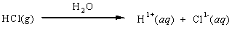
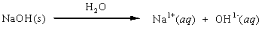
The H¹⁺ ion produced by an Arrhenius acid is always associated with a water molecule to form the hydronium ion, H₃O¹⁺(aq). Arrhenius acids are frequently referred to as proton donors, hydrogen ion donors, or hydronium ion donors, depending on whether we are trying to emphasize the species liberated by the acid (proton or hydrogen ion) or the species present in solution (hydronium ion). To represent the transfer of the H¹⁺ ion to water to form the hydronium ion, we must include H₂O in the chemical equation for acid ionization.

