Discussion Project

Prepare Excel file for the Maxwell Boltzmann Equation below.
Be able to change M (Molar Mass) and T Temperature and Plot. Finish f(v) and f(KE) and illustrate both Temperature and Mass effect (if any) on both. Due Wednesday 23rd by email

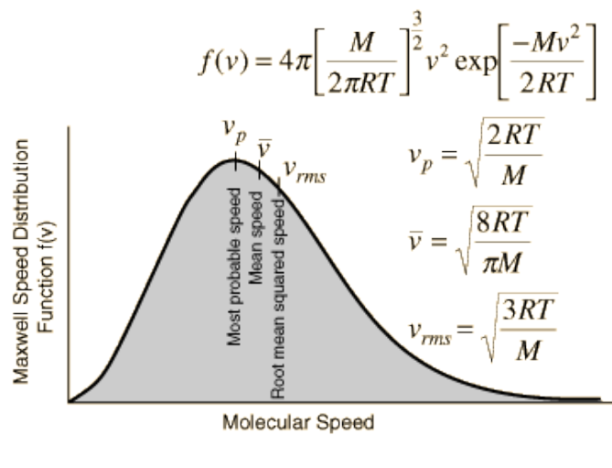

Monday’s (9/21) Individual Homework Assignment will be to work through derivation of above Boltzmann Equation starting from the Maxwell-Boltzmann Distribution and solving for <v²> and also <v>. Show me integral forms used!

Monday’s (9/21) Group Assignment will be to select 4 gases (One simple Atomic, One simple Inorganic Diatomic, One larger Inorganic and One Organic and Plot Both C_{p} and C_{v} as a function of TEMPERATURE. Comment on why these values are changing!

 |  | Cyclic Process for Simple Diatomic
Equil State | A | B | C | D | E
P(atm) | 1 | 10 | 10 | 1 | 1
V(L) | 1 | 1 | 4 | 4 | 1
Temperature | 12.19 | 121.87 | 487.49 | 48.75 | 12.19
R(check) | 8.314 | 8.314 | 8.314 | 8.314 | 8.314
U(Translation Energy Only) | 151.9875 | 1519.875 | 6079.5 | 607.95 | 151.9875
U(Internal Energy) | 253.3125 | 2533.125 | 10132.5 | 1013.25 | 253.3125 | Joules/mole
PV | 101.325 | 1013.250 | 4053.000 | 405.300 | 101.325
 |  | ΔU(AB) | ΔU(BC) | ΔU(CD) | ΔU(DE) | Cycle
ΔU |  | 2279.8125 | 7599.375 | -9119.25 | -759.9375 | 0
 |  | Q(Heat)
 |  | 2279.8125 | 10639.125 | -9119.25 | -1063.913 | 2735.8
 |  | Work
 |  | 0 | -3039.75 | 0 | 303.975 | -2735.8
 | ΔH | 3191.738 | 10639.125 | -12766.950 | -1063.913 | 0
 | H/ΔT=Cp | 29.099 | 29.099 | 29.099 | 29.099
W=-(P2-P1)*(V2-V1)= |  | -2735.8 | Joules
 |  | ΔT(AB) | ΔT(BC) | ΔT(CD) | ΔT(DA)
 |  | 109.685 | 365.618 | -438.742 | -36.562
 |  | C_{v}(1-2) | C_{p}(2-3) | C_{v}(3-4) | C_{p}4-1)
 | Q/DT | 20.785 | 29.099 | 20.785 | 29.099
 |  | 5/2R= | 20.785
 |  | 7/2R= | 29.099 |  | 1 bar = 0.986923267atm
 |  |  |  |  | 1.01325 | bar= 1atm
 |  |  |  |  | 1atm*liter=101.325 Pa m³
ASSIGNMENT Finish for Friday night!!!! (Midnight)
Use to prove H and E are path independent while Q and W are NOT!!!
This will require multiple examples to be submitted as different “sheets”

