In the upper Atmosphere there is an Equilibrium thus fixed level of ¹⁴C largely resulting in ¹⁴CO₂
*Reasonable assumption that these rates are constant.
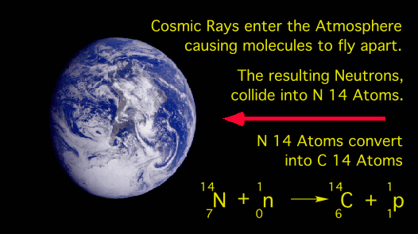


After an Organism death, it “leaves” this cycle and ONLY decays with a half-life of 5715 years
