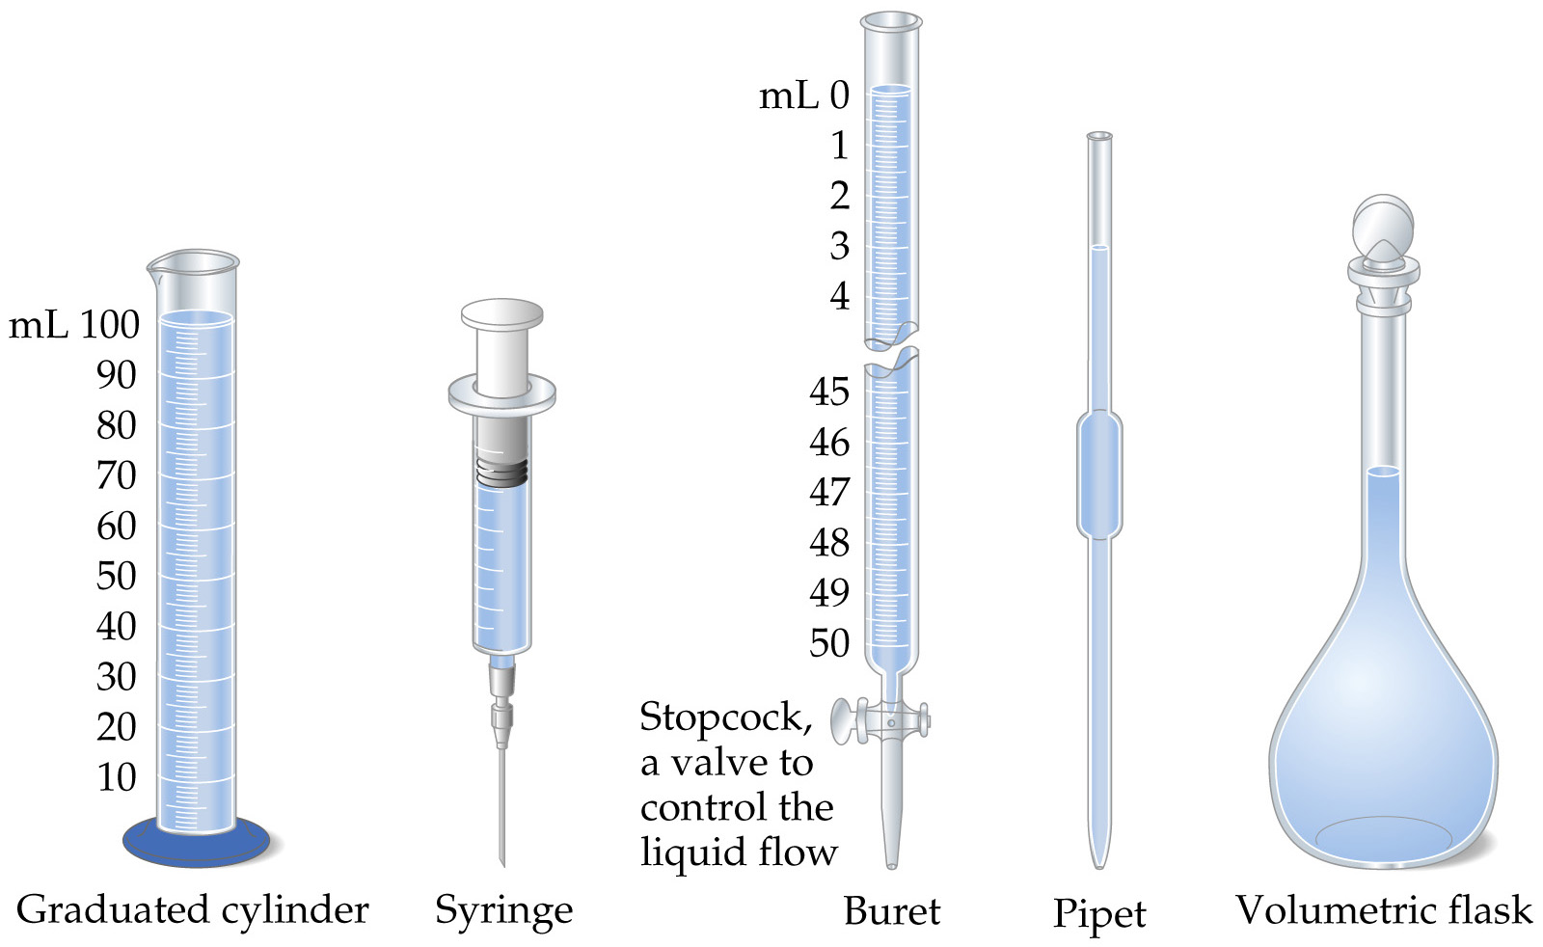

Chemical Containers used to Measure Volume

